Tasks On Docker -01

- Setup a virtual machine using Ubuntu image.

Create a new Instance using Ubuntu
AWS Console→Launch Instance→Name→Select AMI→
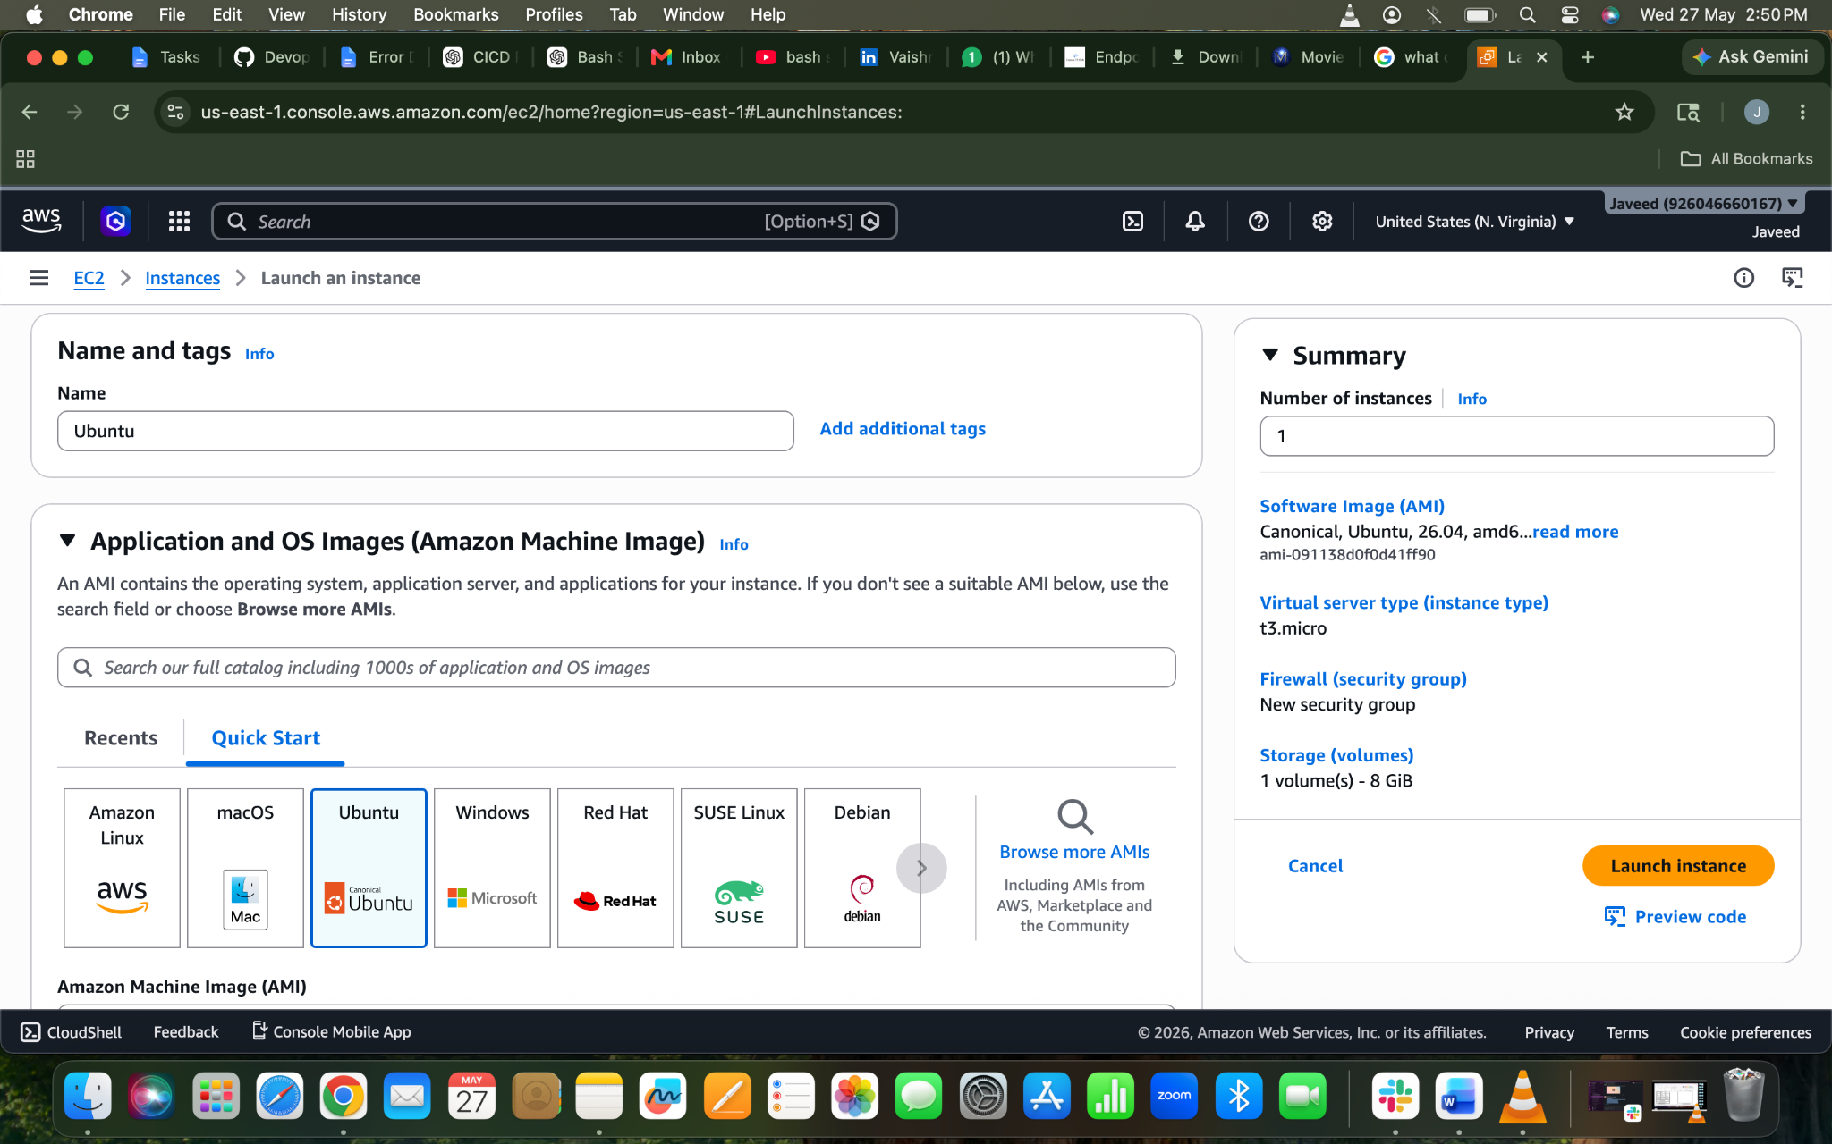
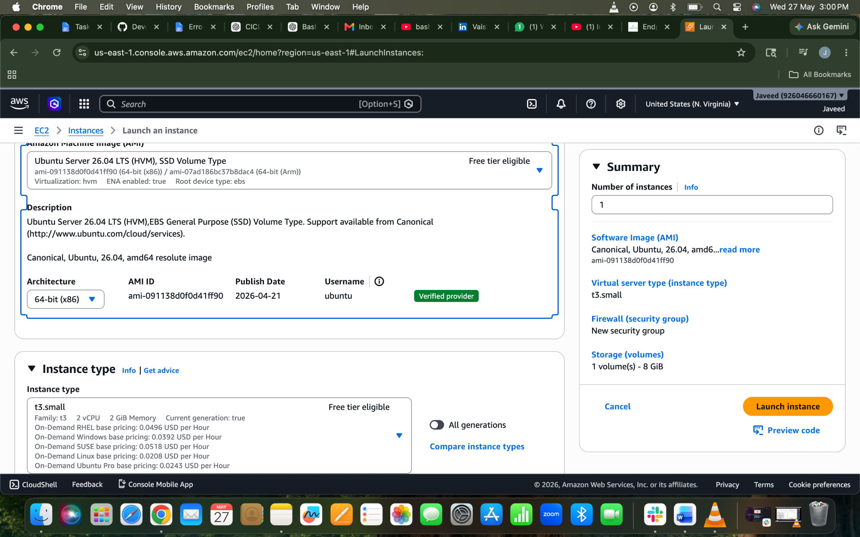
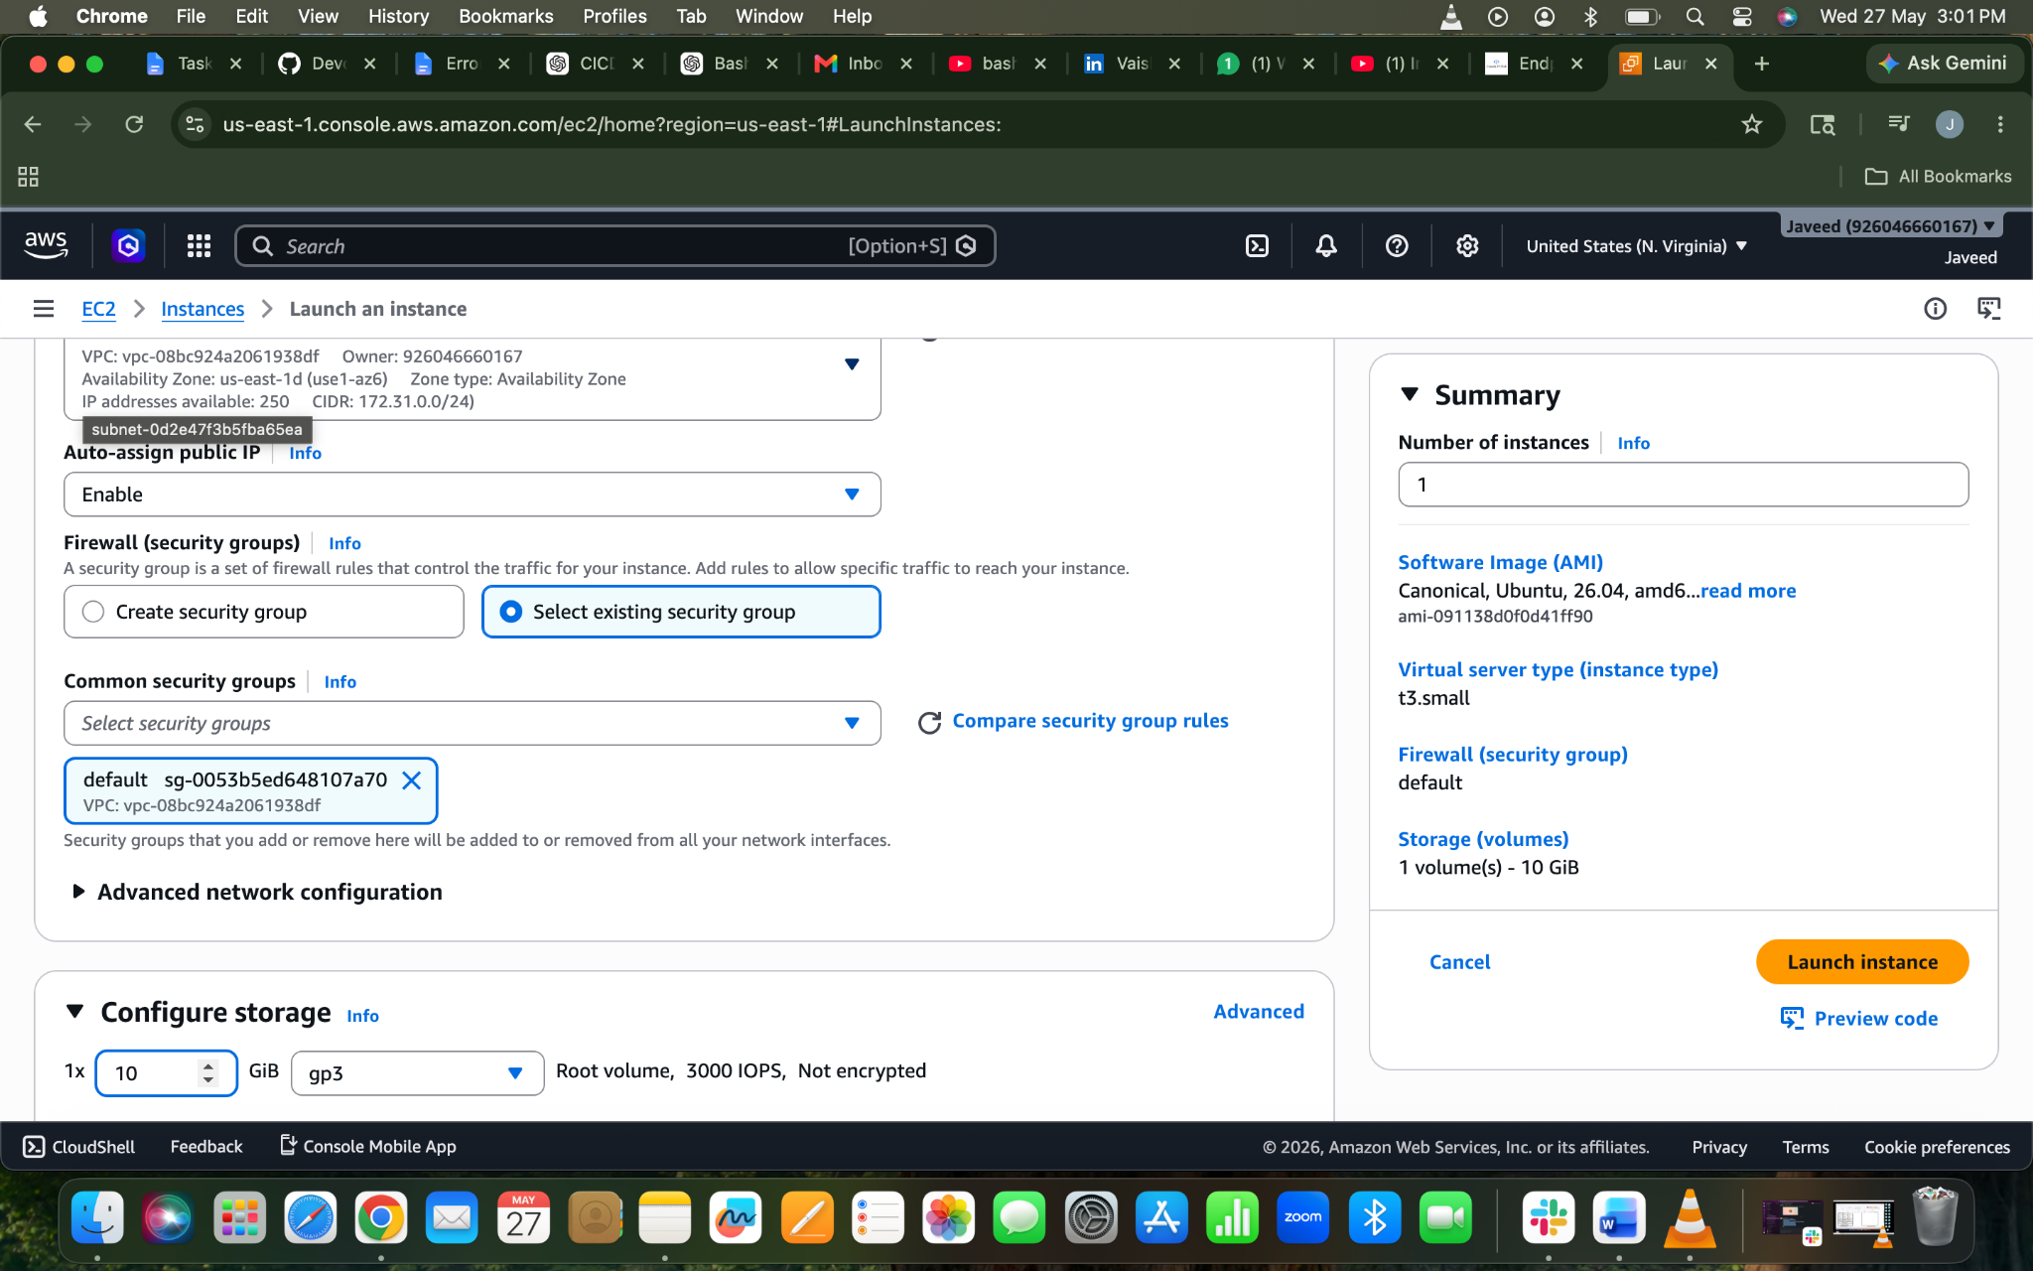
Launched an Instance using Ubuntu Image
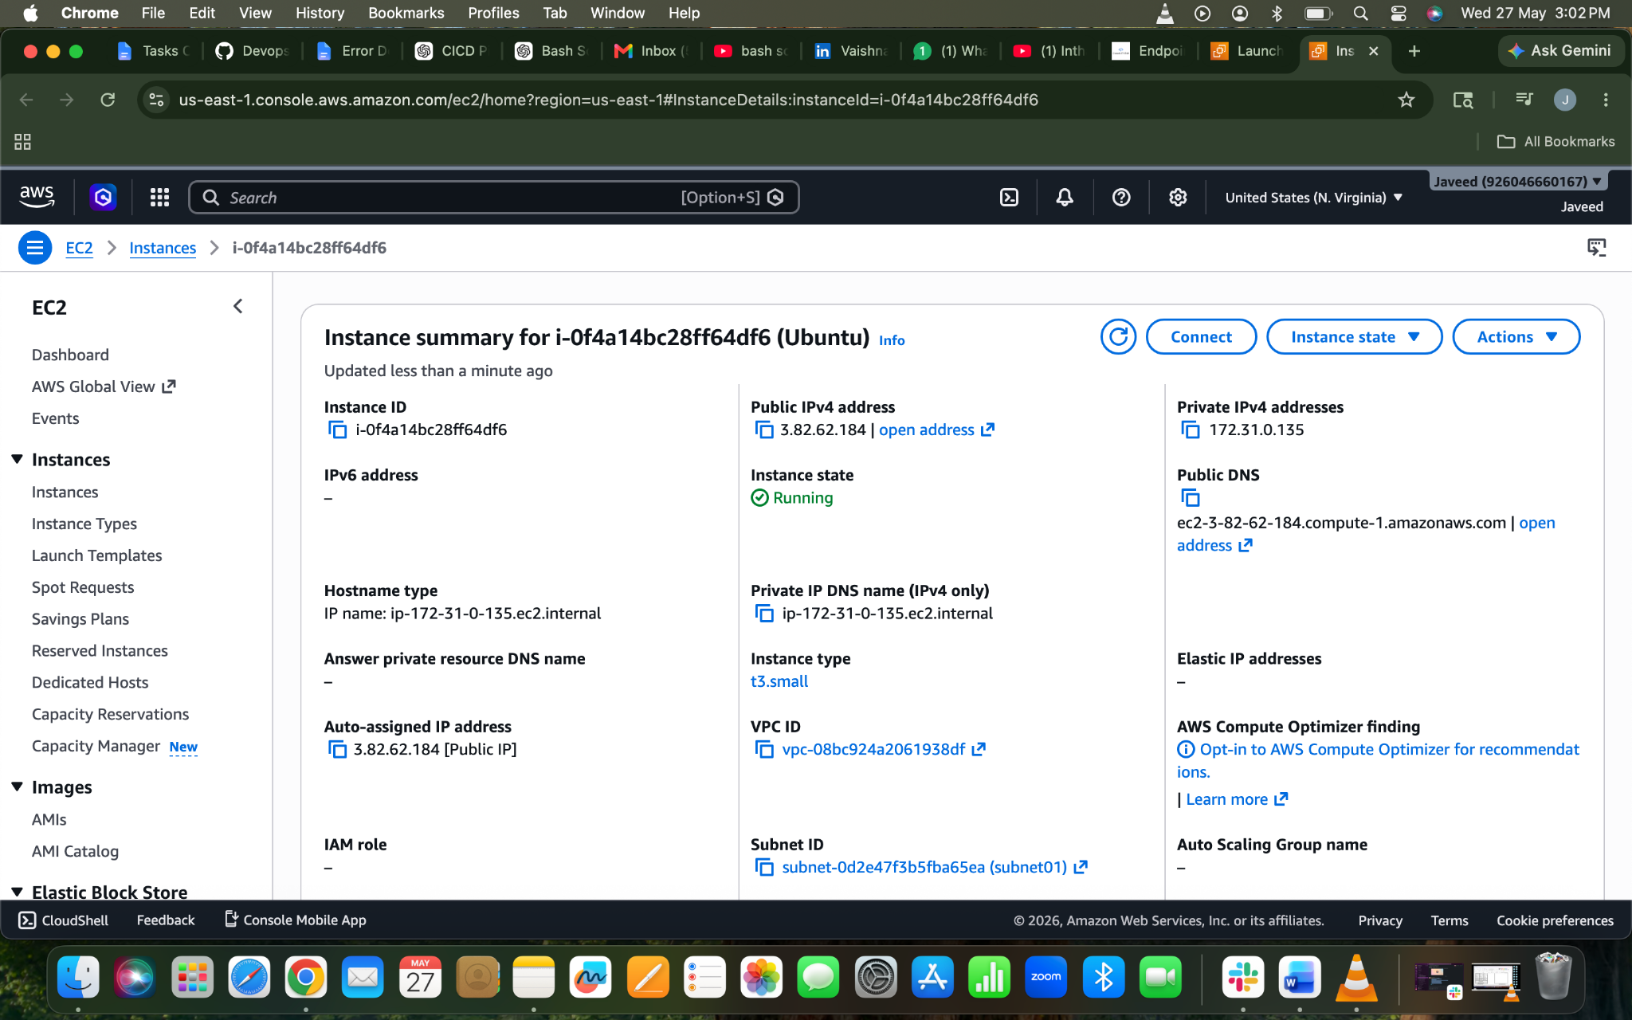

- Install docker on ec2.
Lets Login to our ec2 instance
Instance → Connect→ec2 connect
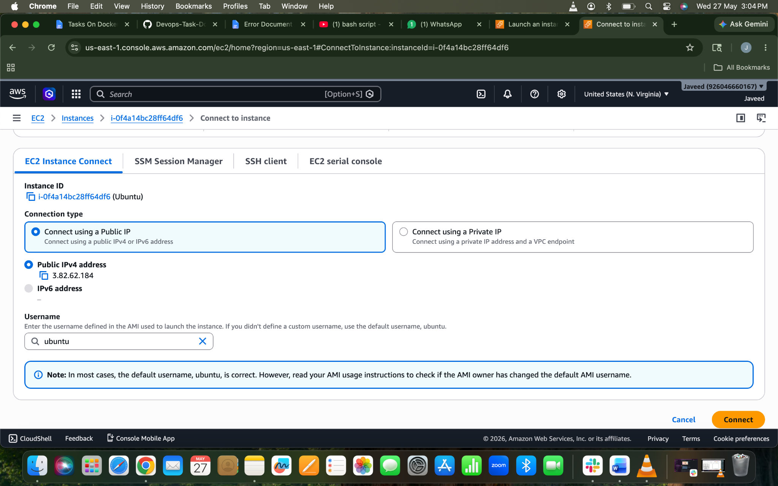
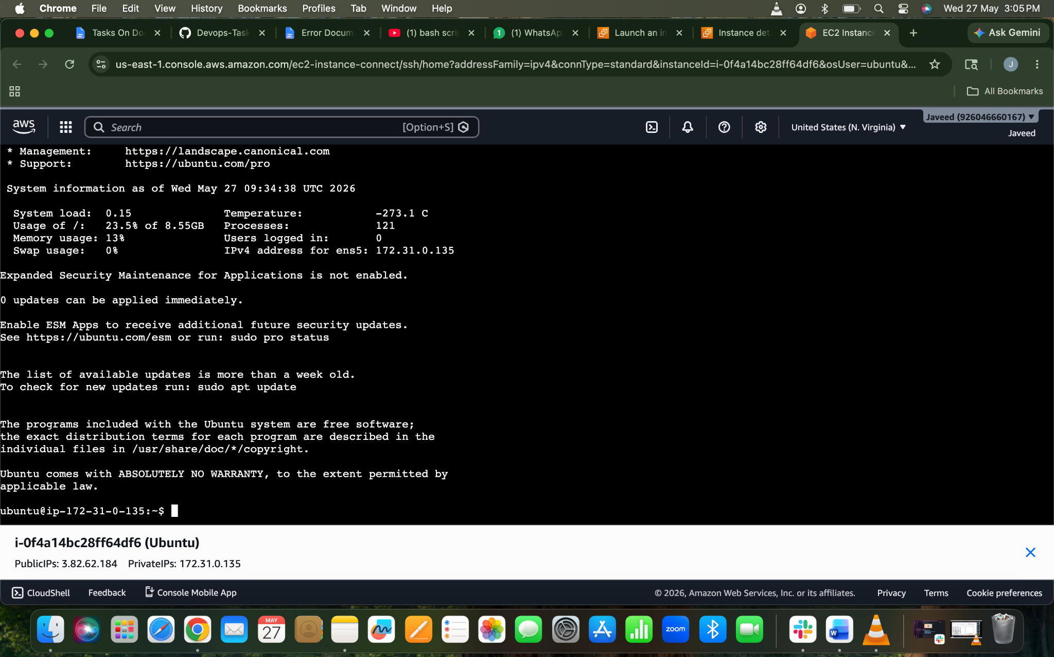
Lets Install docker on our newly created image using command
apt update ⇒ to update the packages
apt install docker.io -y
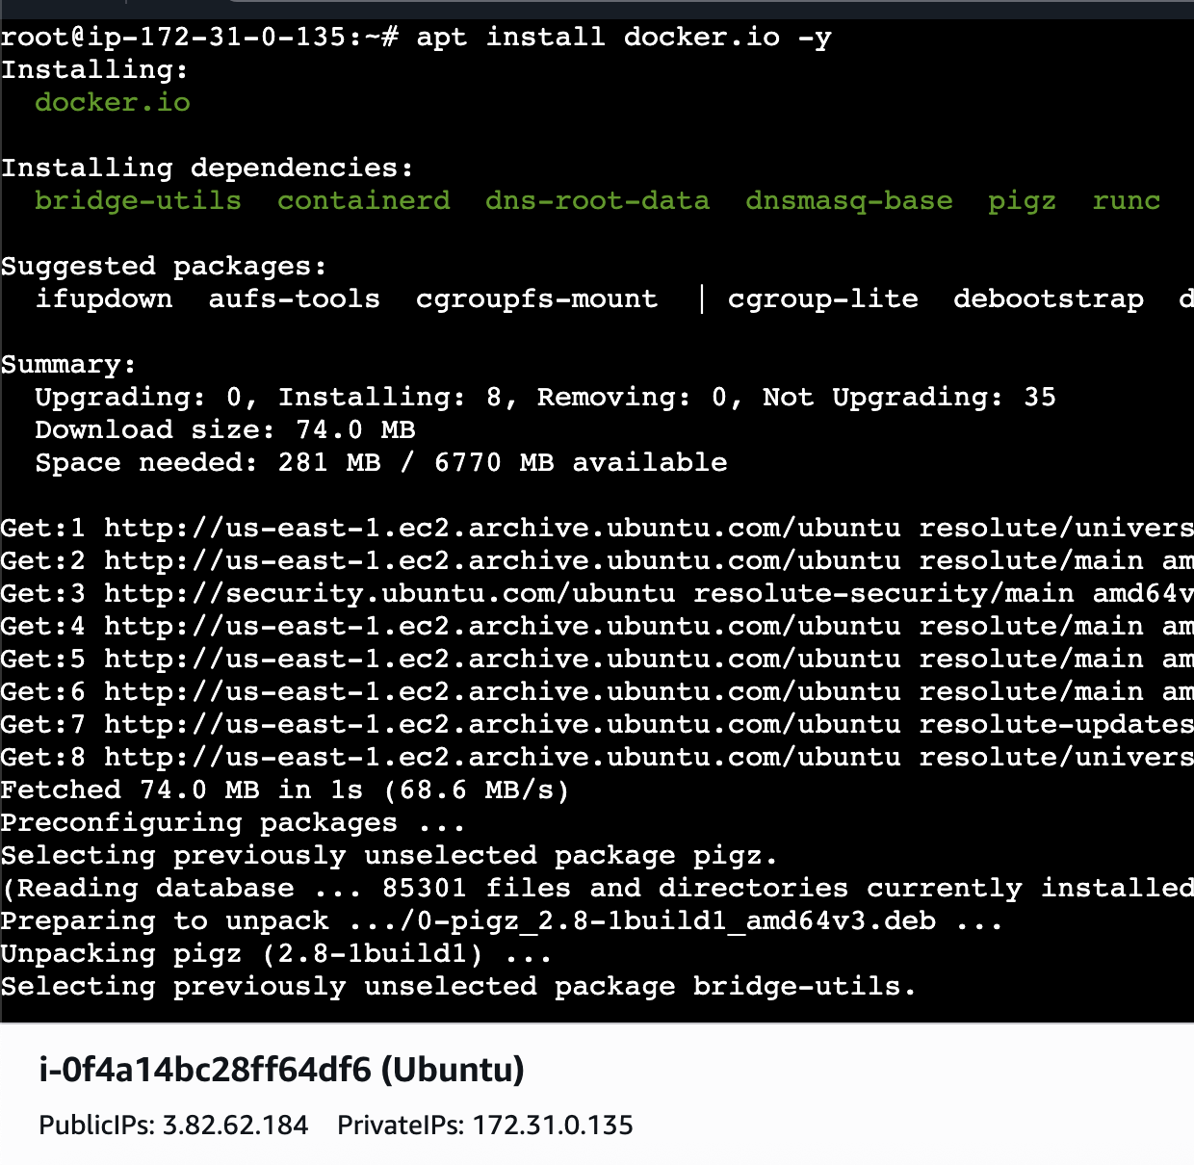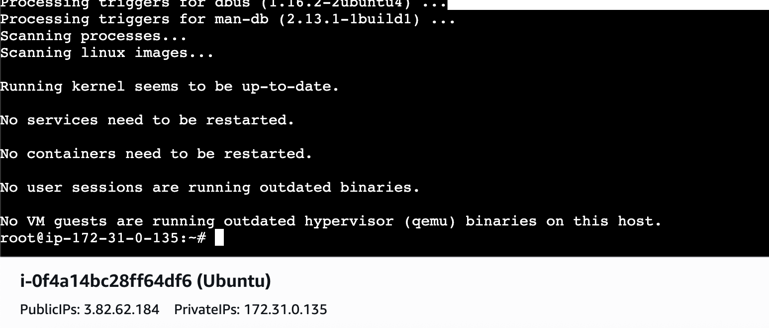
Docker Installed on our EC2
Docker –version to check
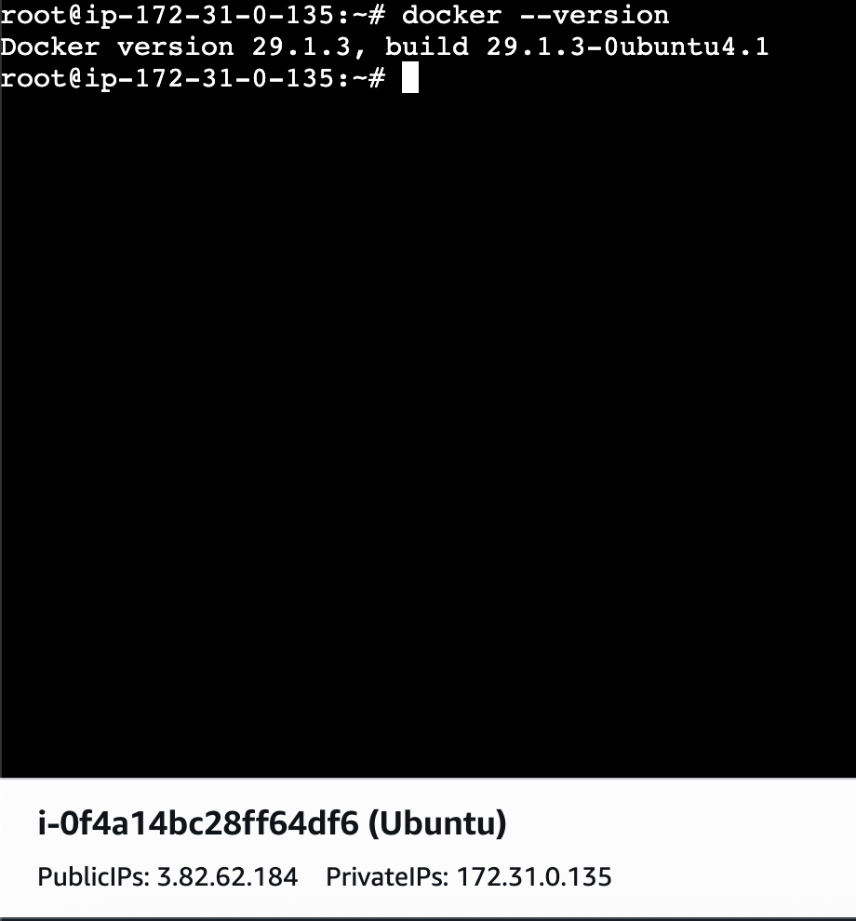
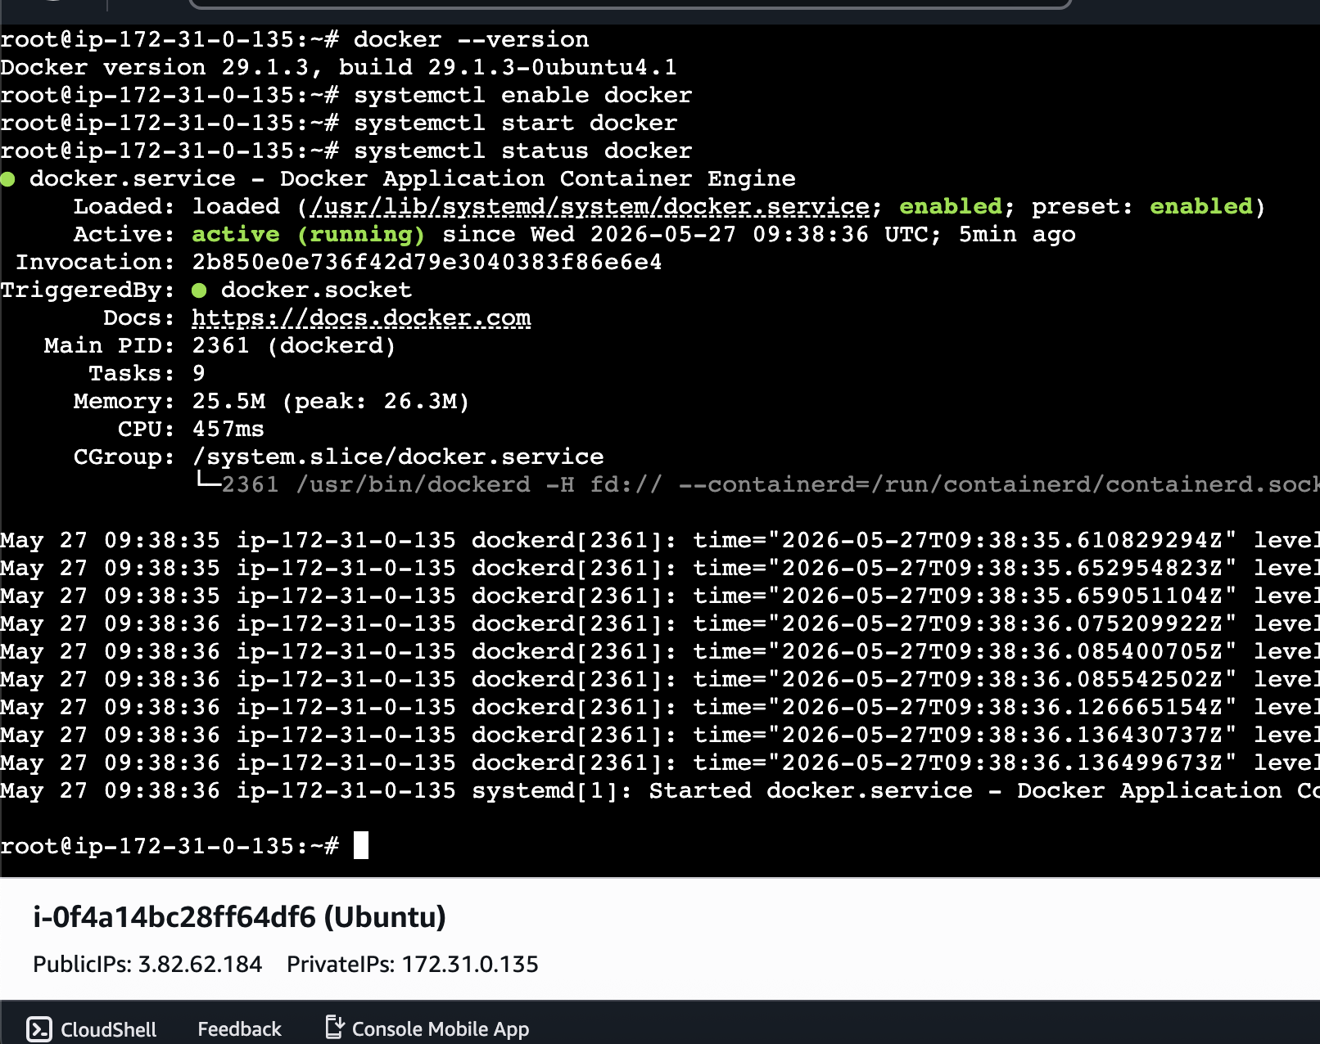

- Pull 5 docker images. (nginx, Apache tomcat, ubuntu, Jenkins, SonarQube)
NGINX:
By using docker pull nginx we can pull the image
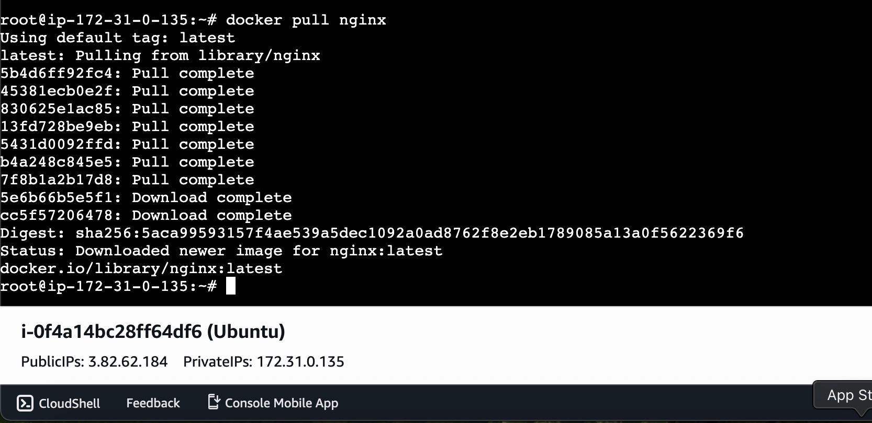
Apache Tomcat:
docker pull tomcat
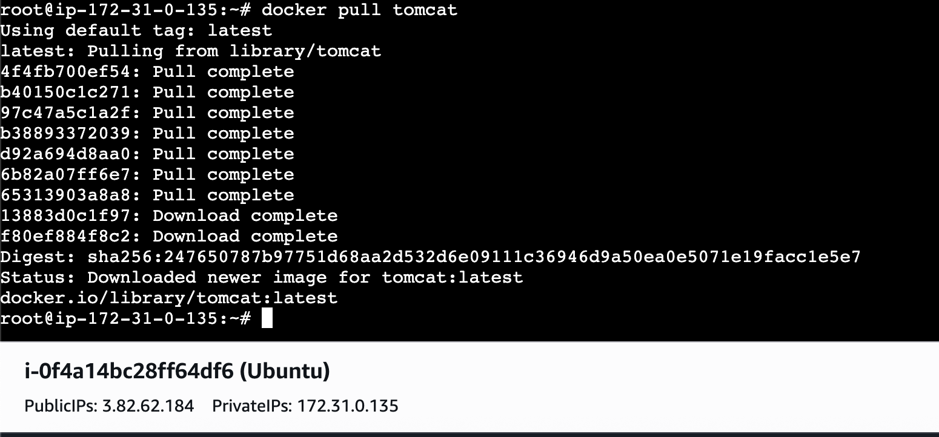
UBUNTU:
Docker pull ubuntu
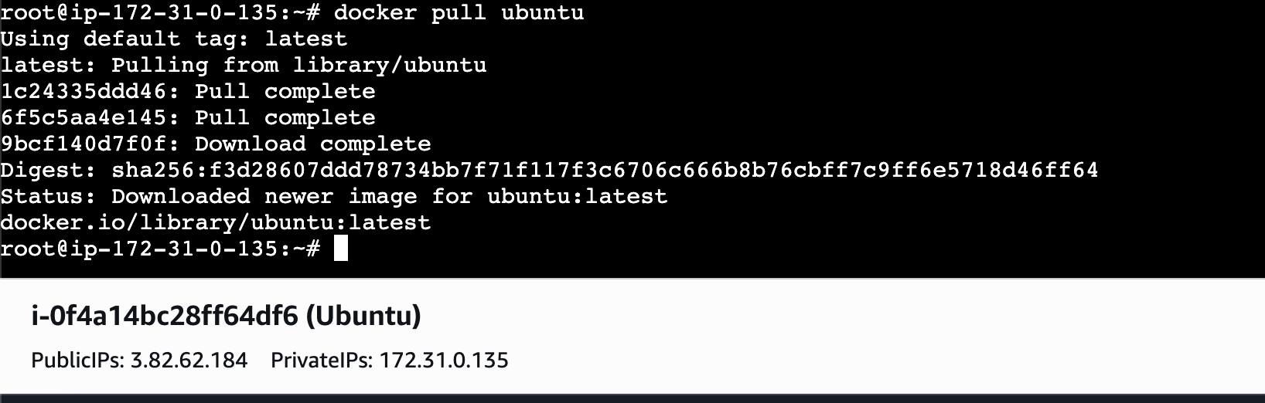
JENKINS:
Docker pull jenkins/jenkins:lts
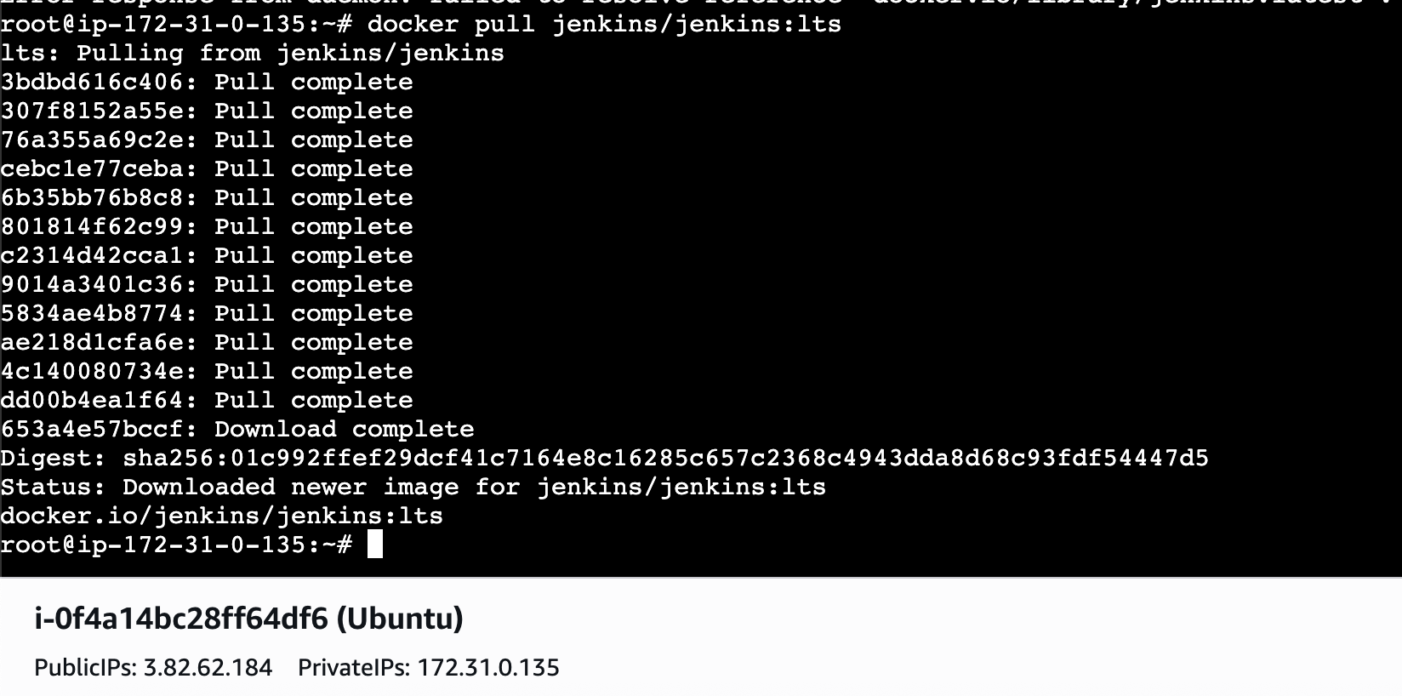
SONARQUBE:
docker pull sonarqube
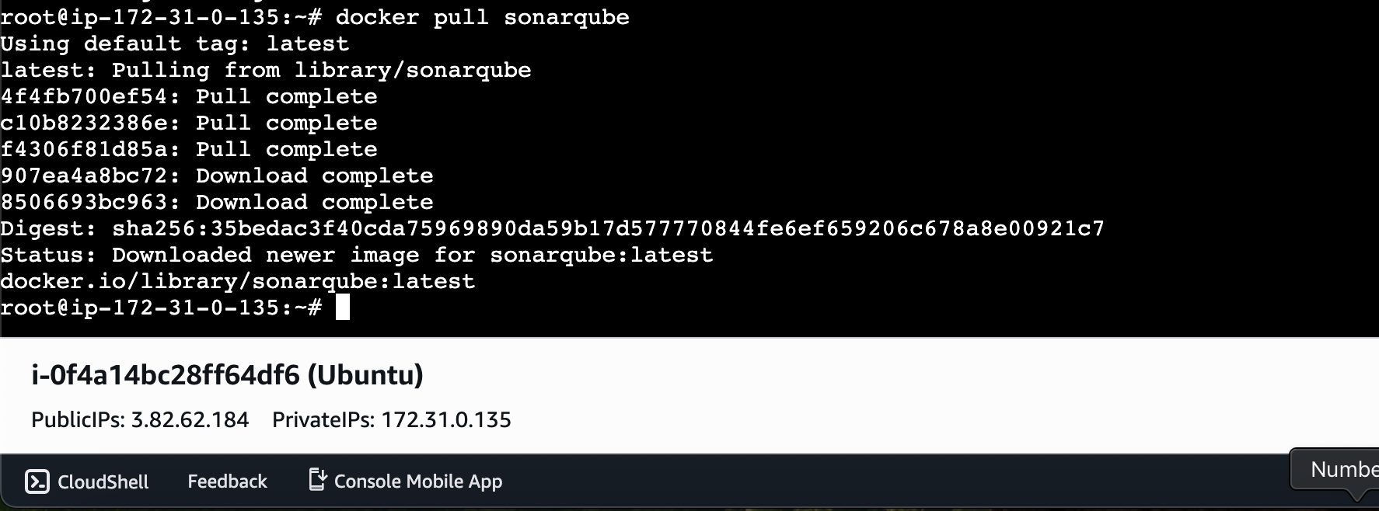
docker images ⇒ To check what what images have been pulled
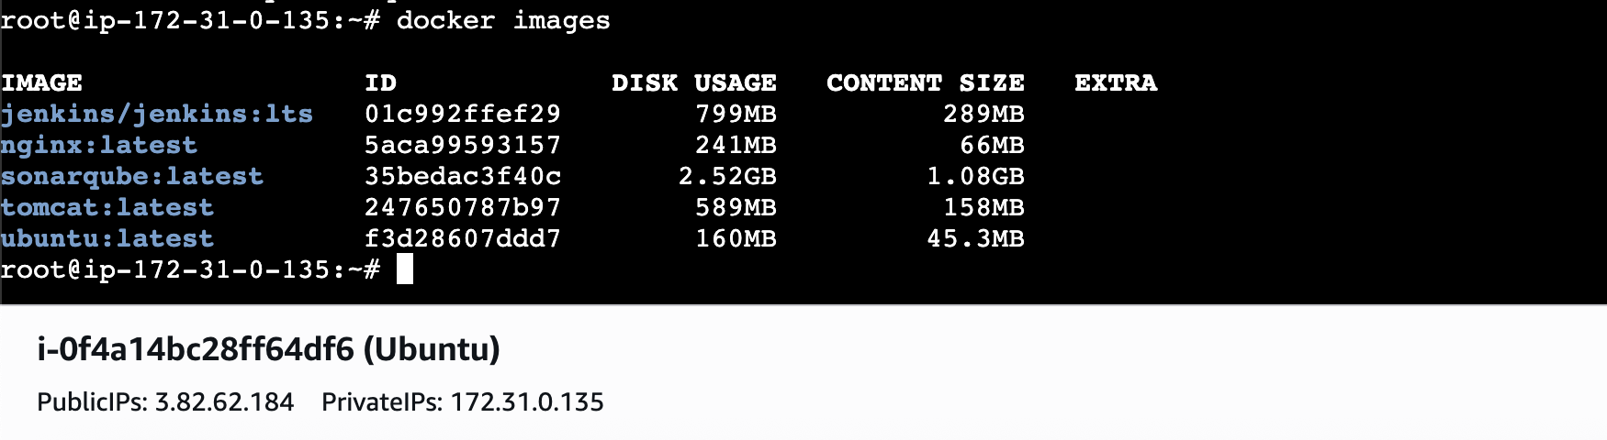

- Run nginx container and expose on port 81.
As we want to run it on port 81 lets open port 81 in our SGs
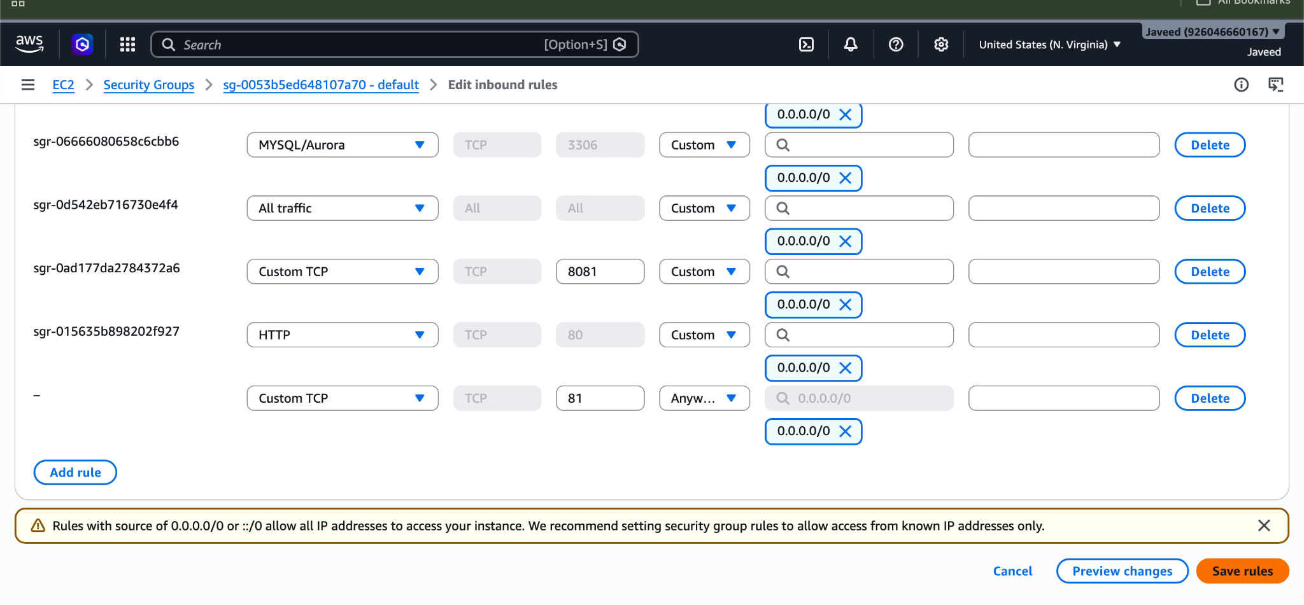
Now use command
docker run -d --name nginx-container -p 81:80 nginx ⇒ By using this command I’m telling docker to create and run new container from this image and map the port to 81
Docker ps ⇒ to confirm our mapping has been done properly or not

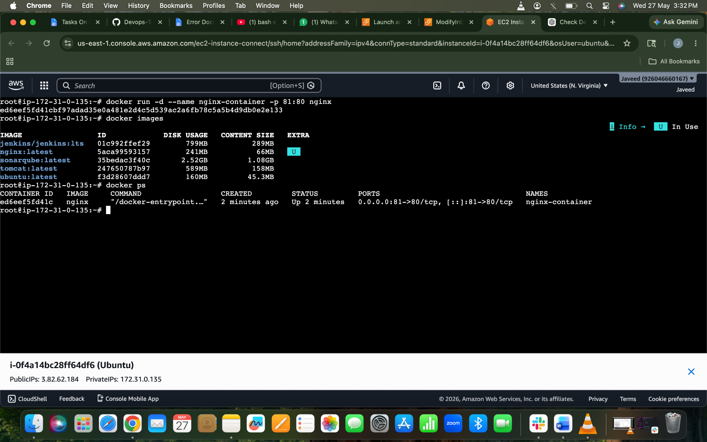
LEts check in browser now using publicIP:81
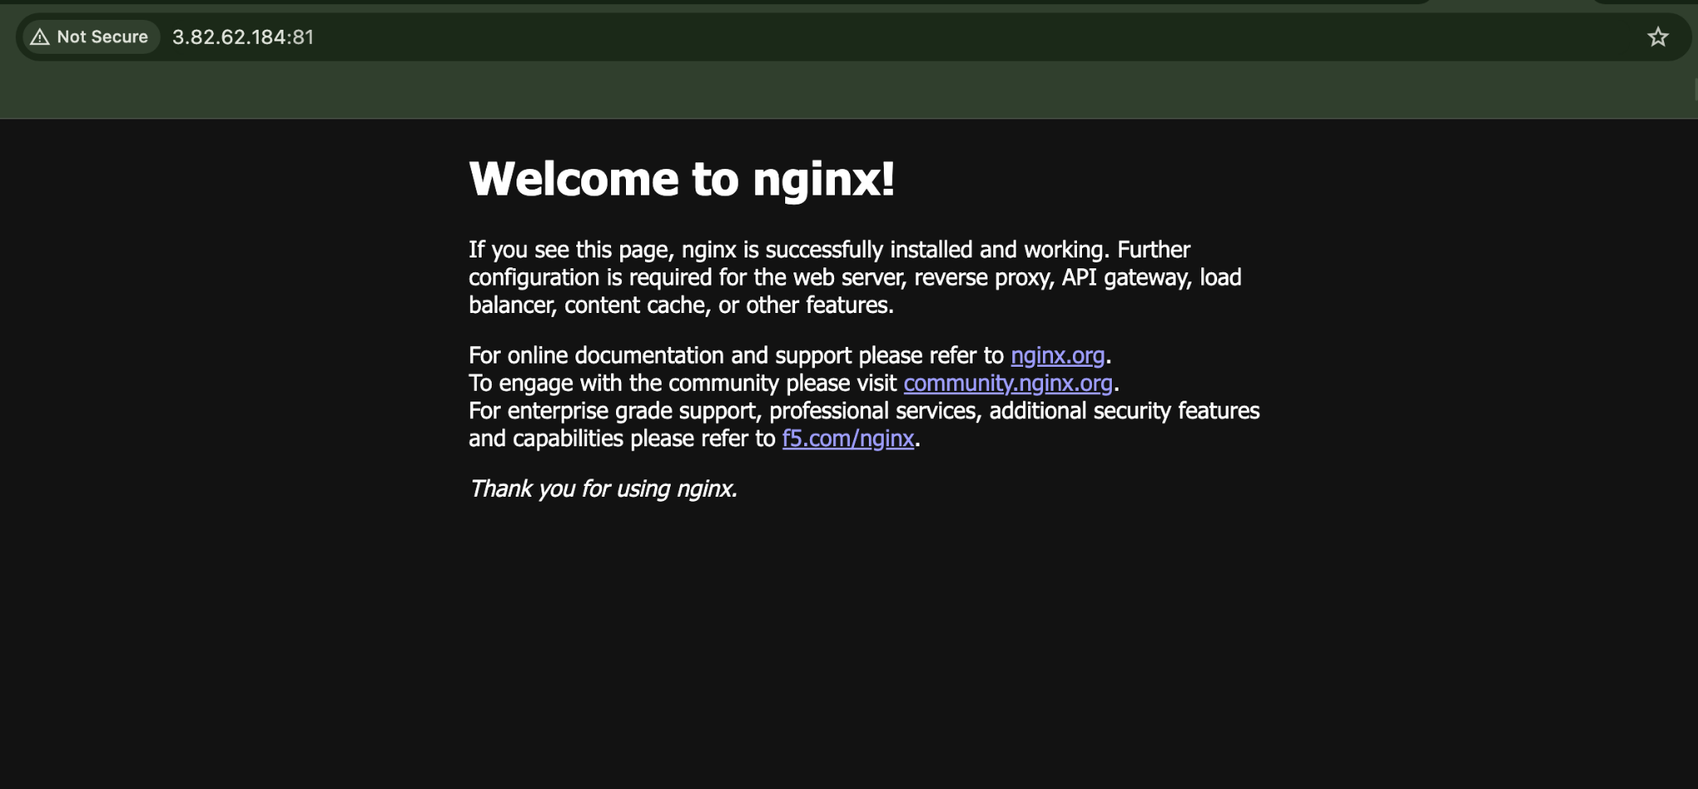
- Delete the Apache tomcat image from local.
To delete the Apache tomcat image from local we can use command
docker rmi tomcat → to delete the images
Docker images → to confirm the image has been deleted
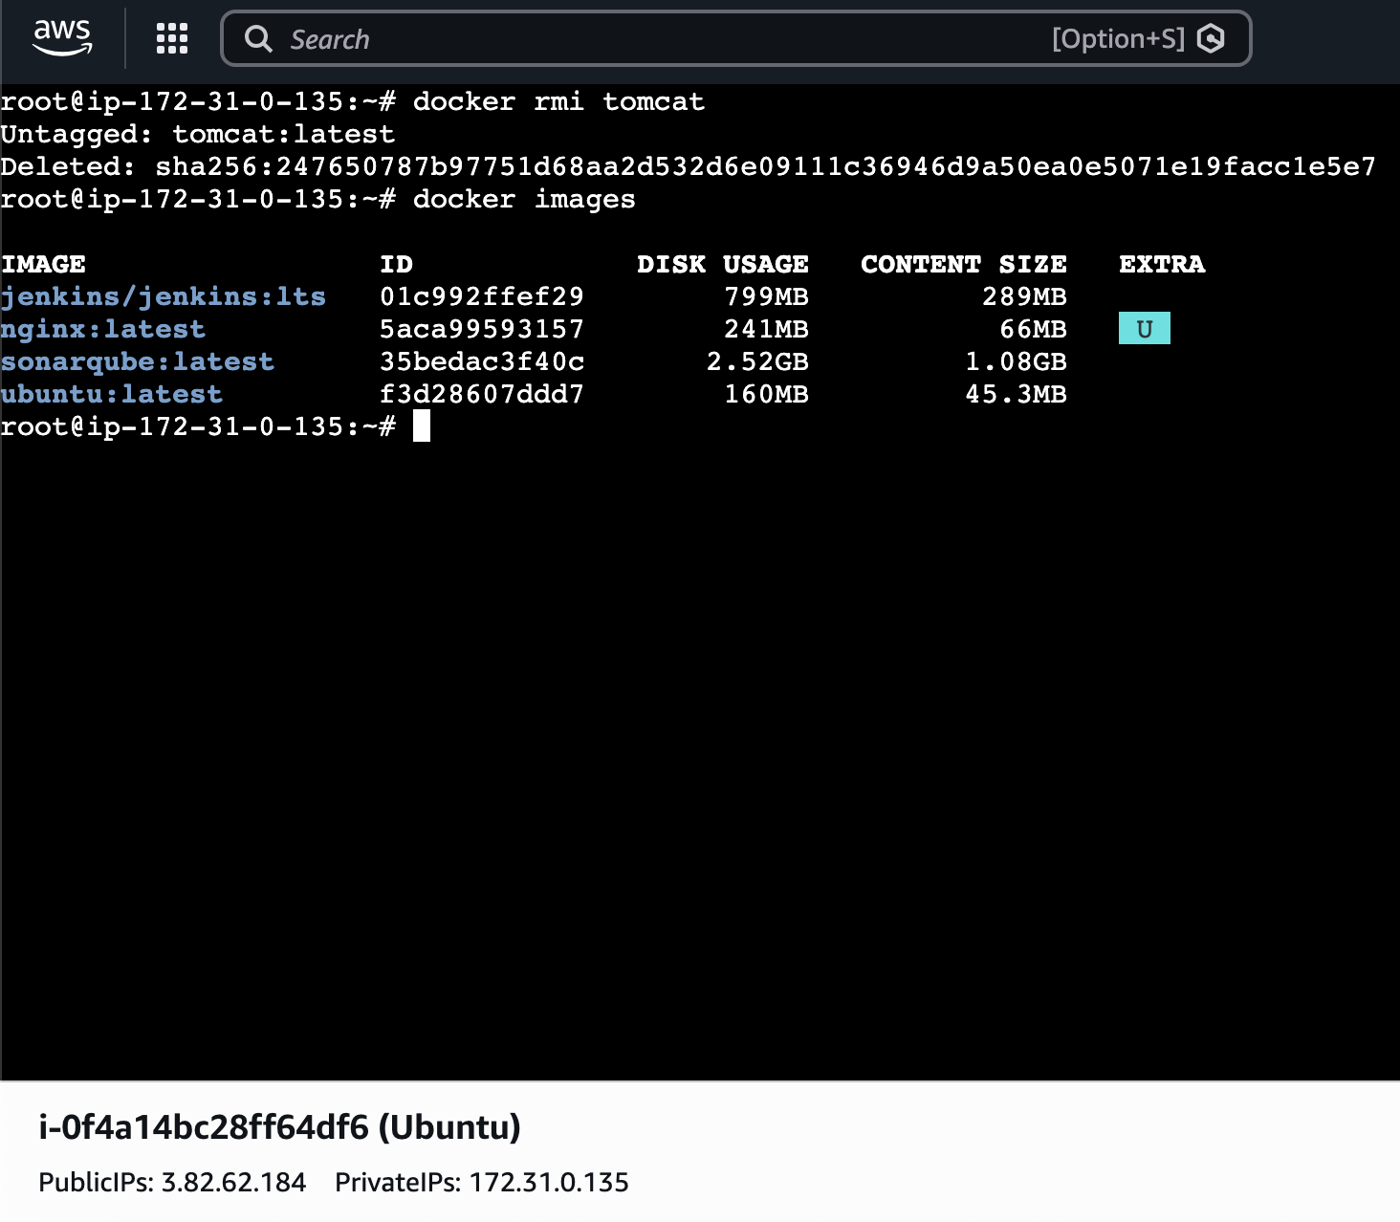

- Inspect the Jenkins image, SonarQube image.
By using docker inspect command we can inspect the images.
Docker Inspect ⇒ is used to get detailed information about a Docker container, image, volume, or network in JSON format.
Such as:
- Container ID
- IP address
- Port mappings
- Environment variables
- Mounts/volumes
- Container status
- Network details
- Image details
- Creation time

docker inspect jenkins
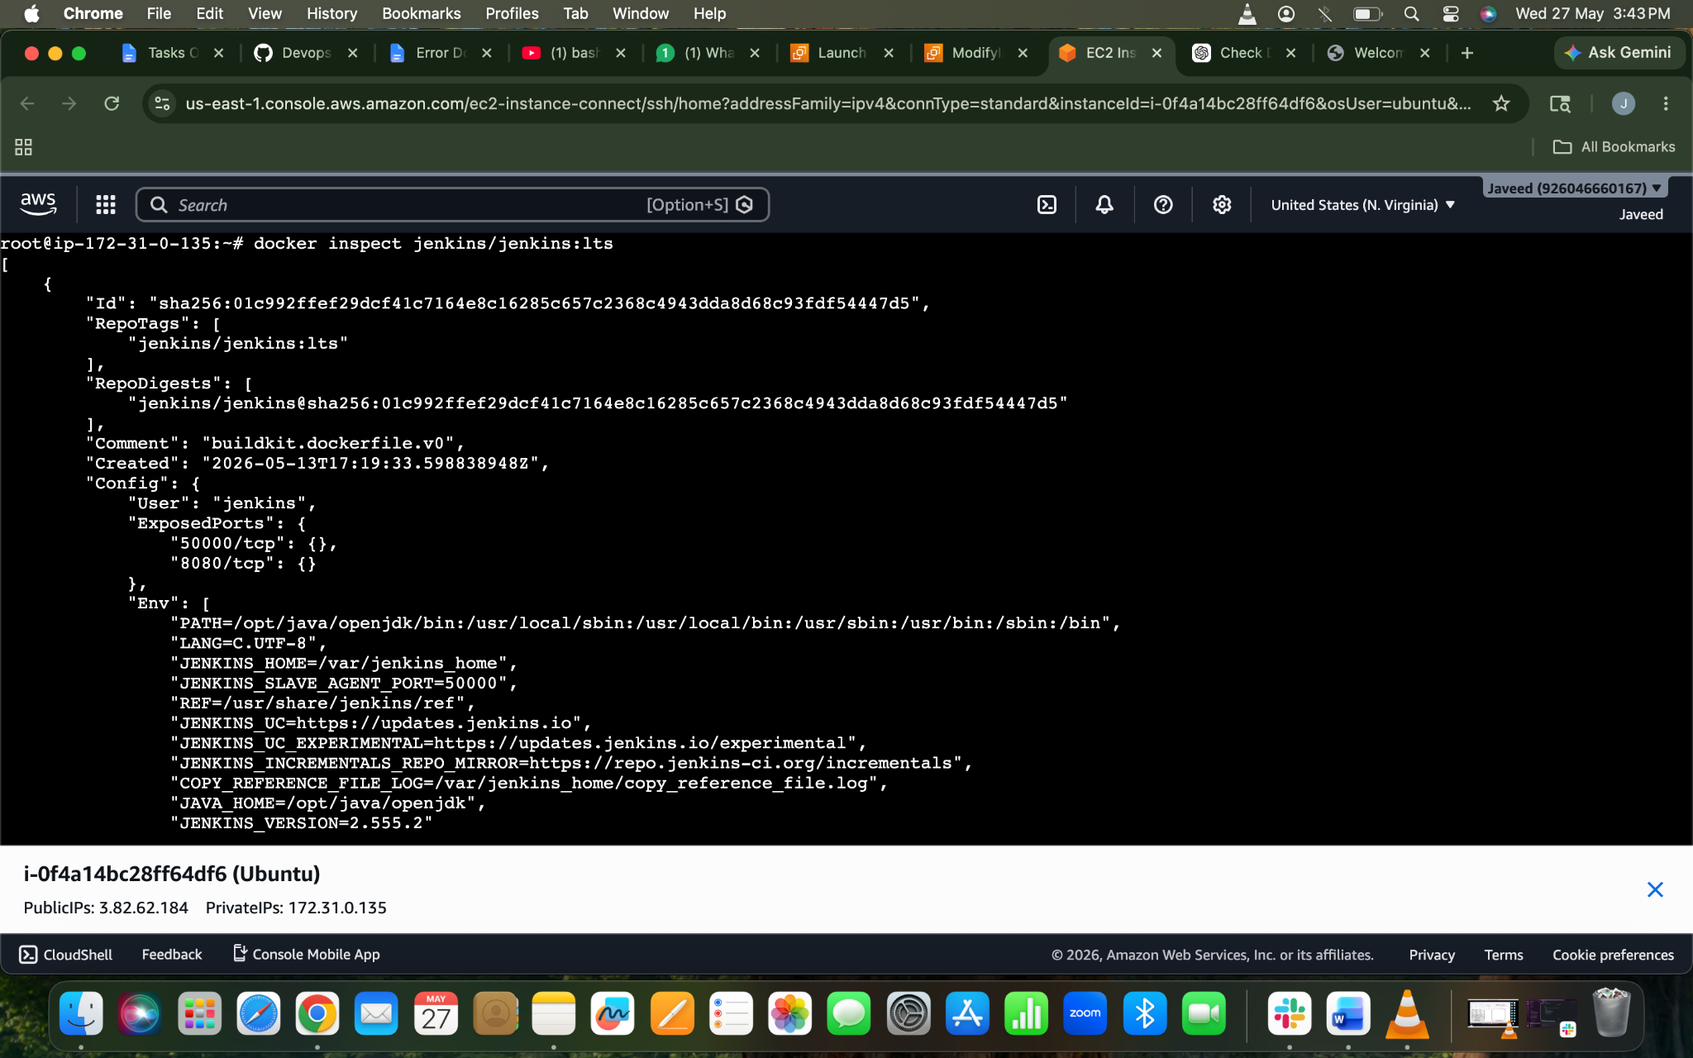
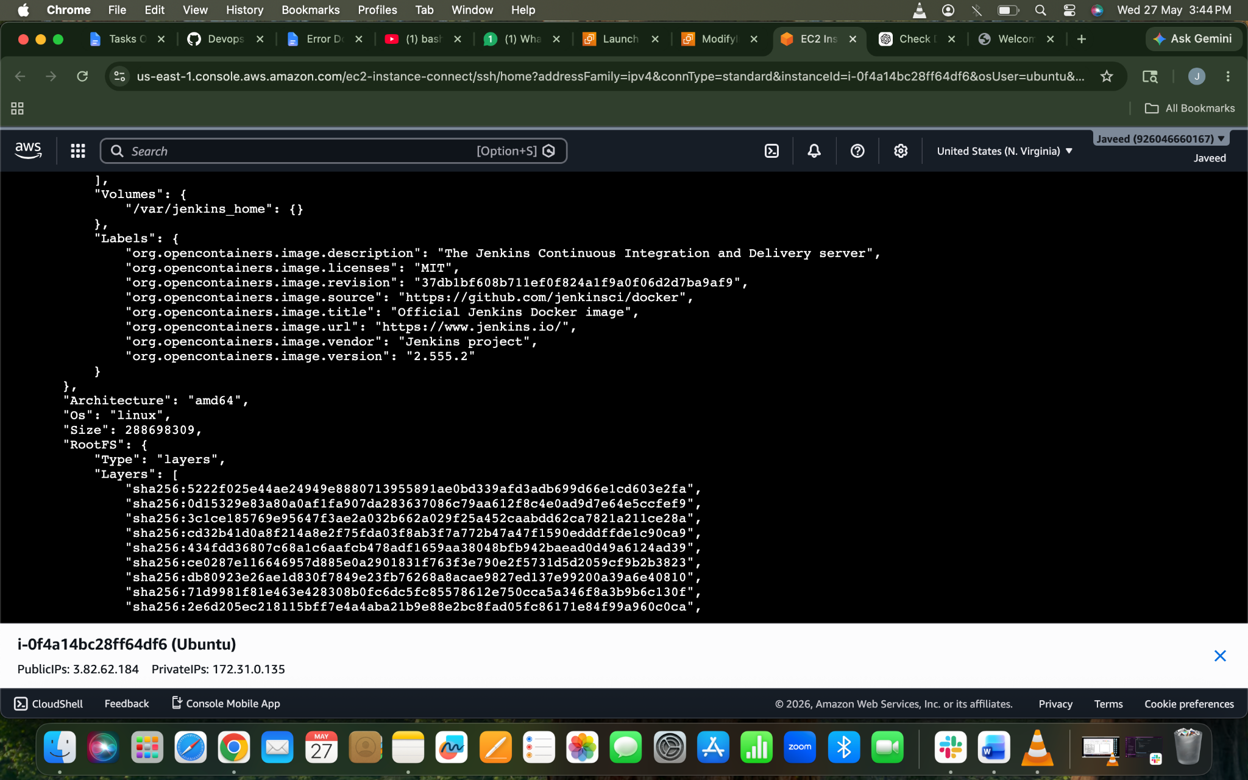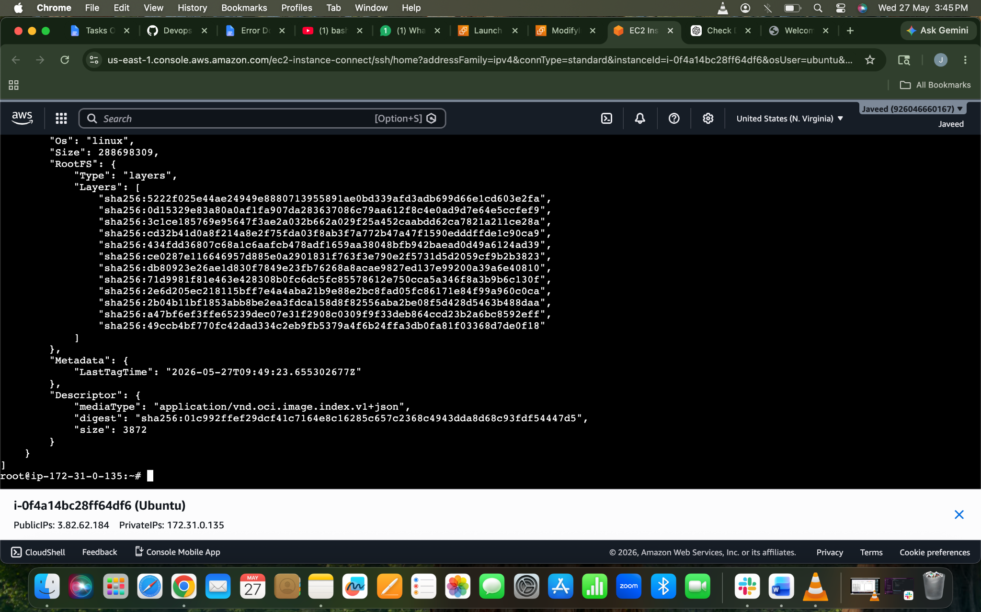

docker inspect sonarqube
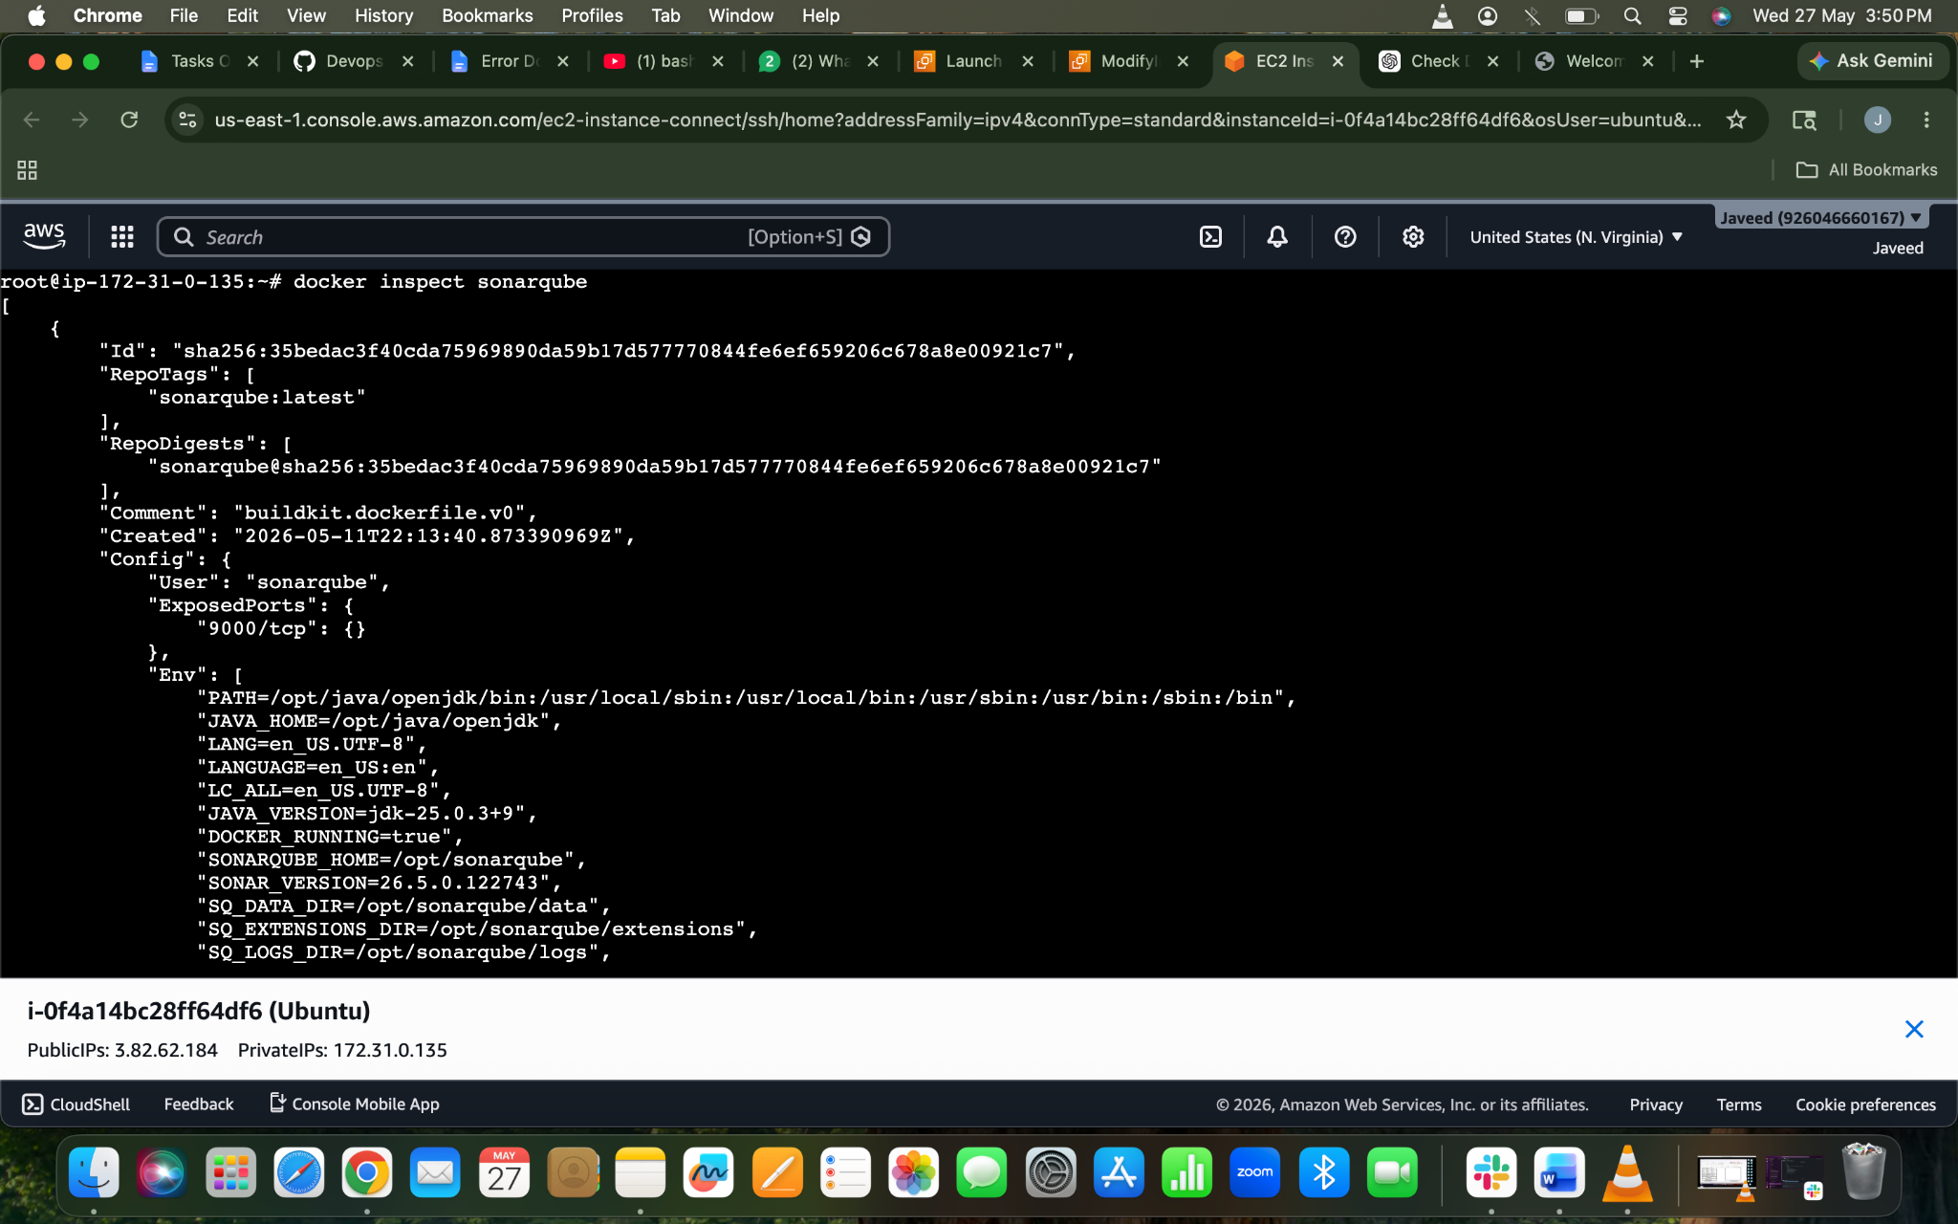
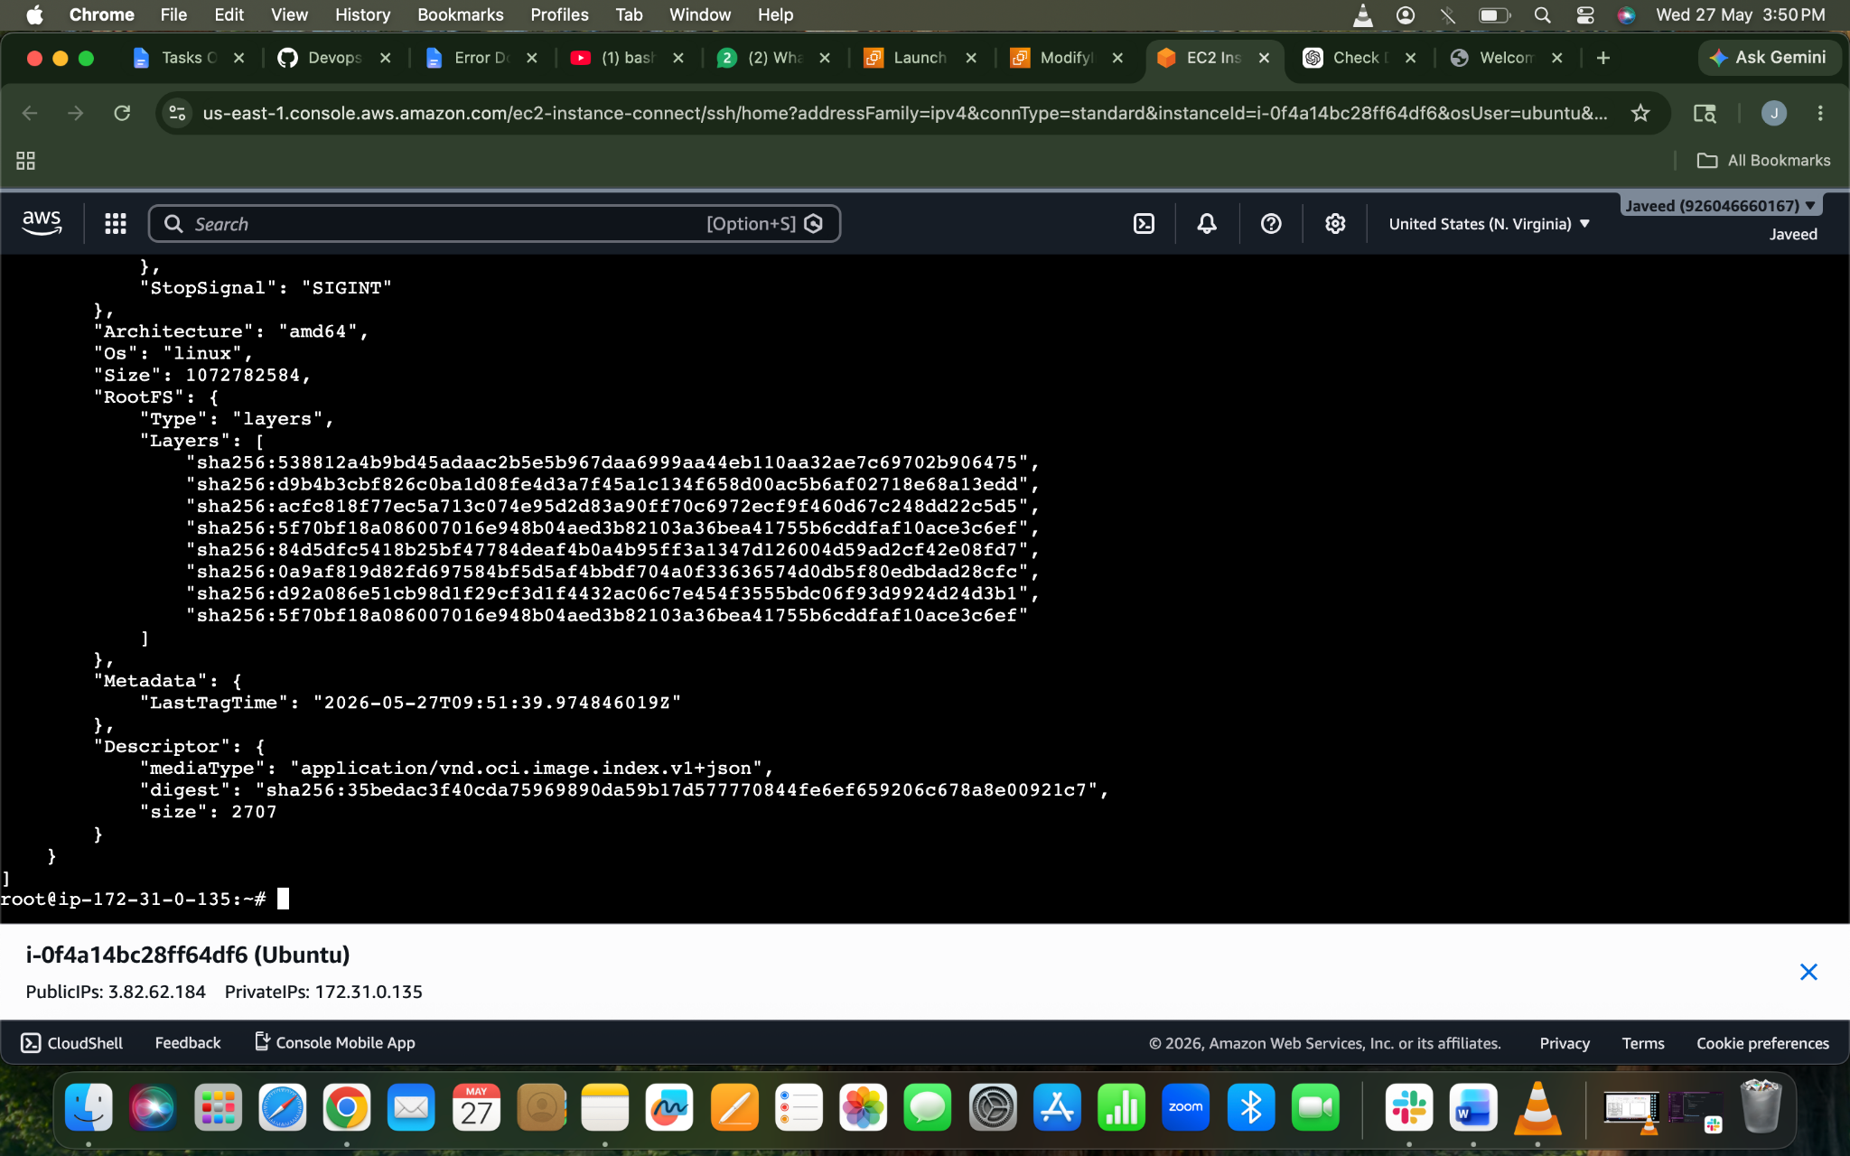

- Run Jenkins container and run one sample job.
By using the below command
docker run -d \
--name jenkins \
-p 8080:8080 \
-p 50000:50000 \
-v jenkins_home:/var/jenkins_home \
jenkins/jenkins:lts
After the be above command now lets use
docker start jenkins
Docker exec -it -u root jenkins bash ⇒ to change to jenkins root user
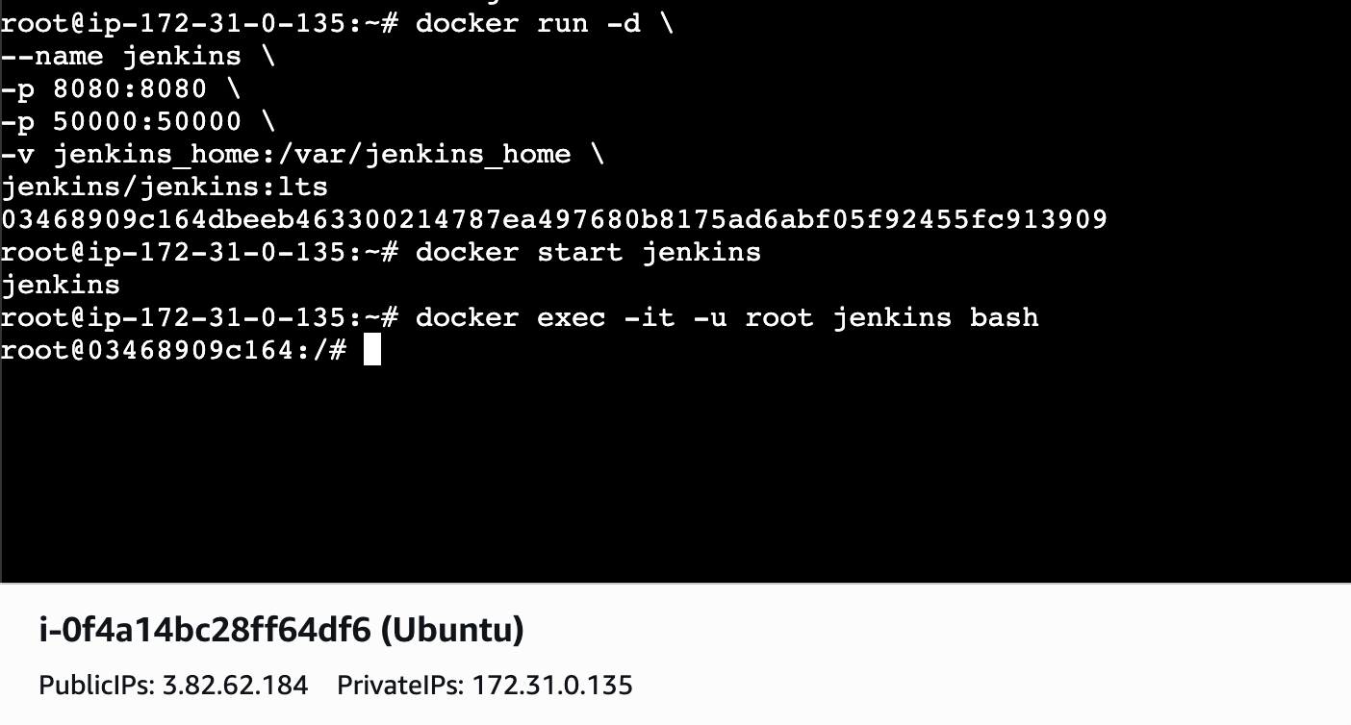
docker exec jenkins cat /var/jenkins_home/secrets/initialAdminPassword ⇒ needs to be done coming out jenkins root user to check the password
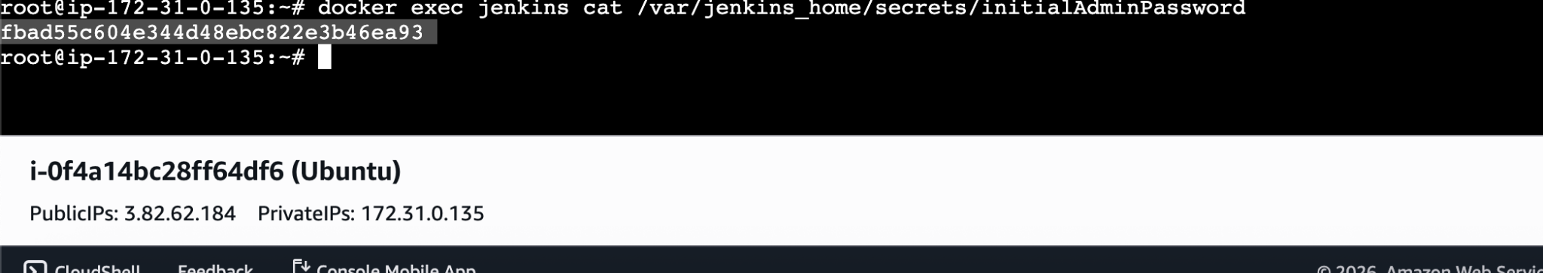
Install plugins→ add user and password→jenkins is ready
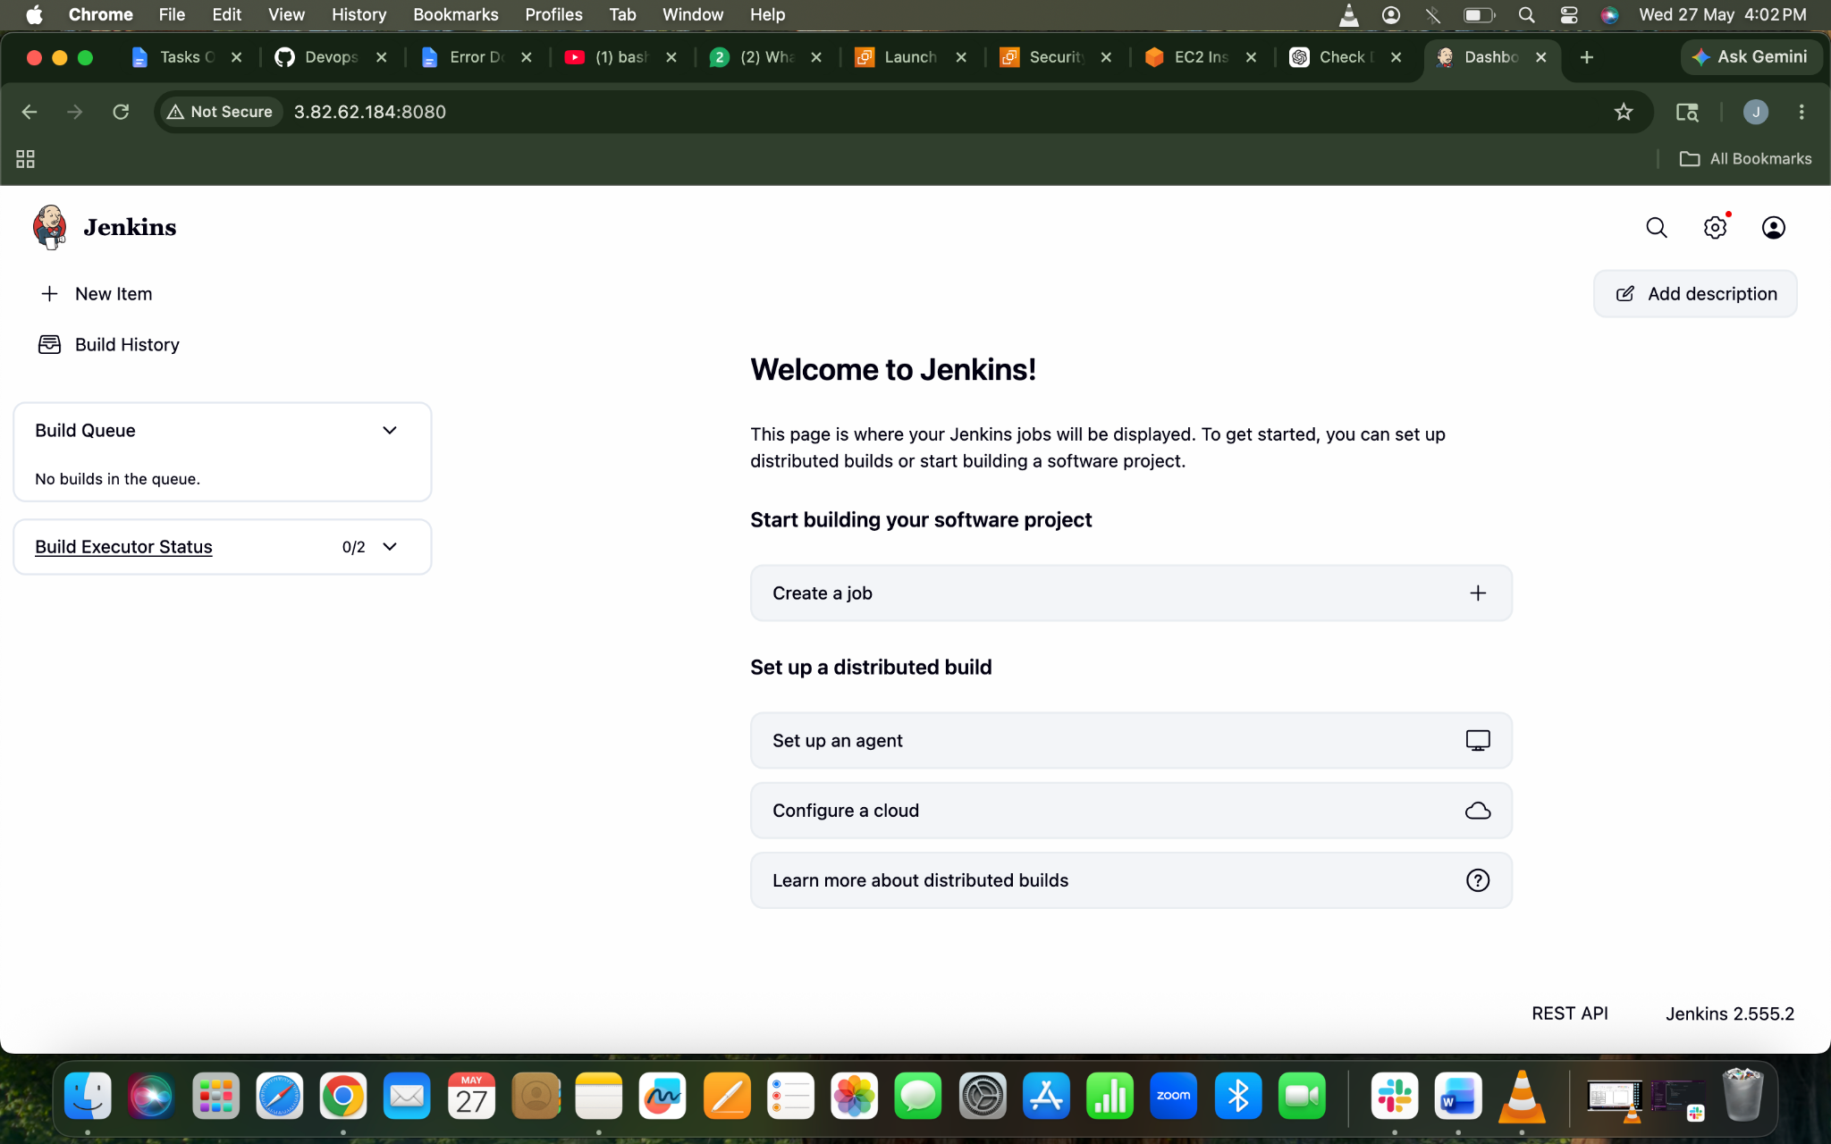
Create a new job
New item→freestyle →
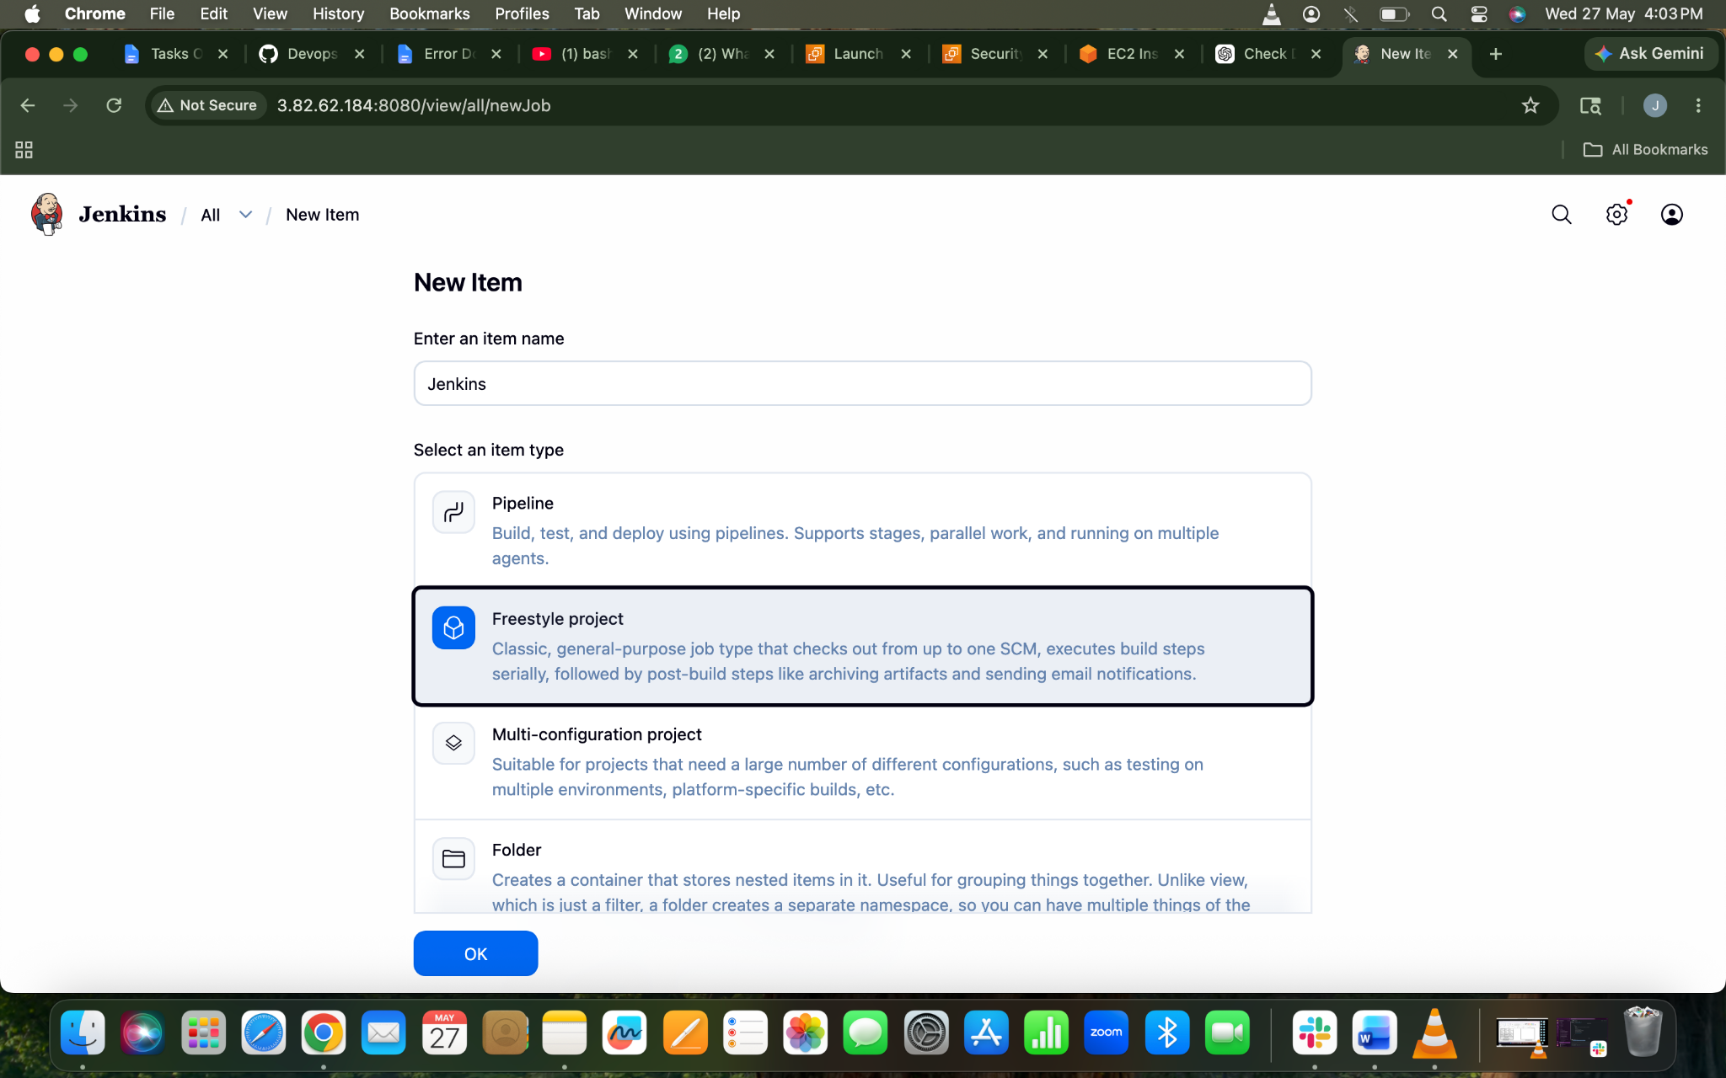

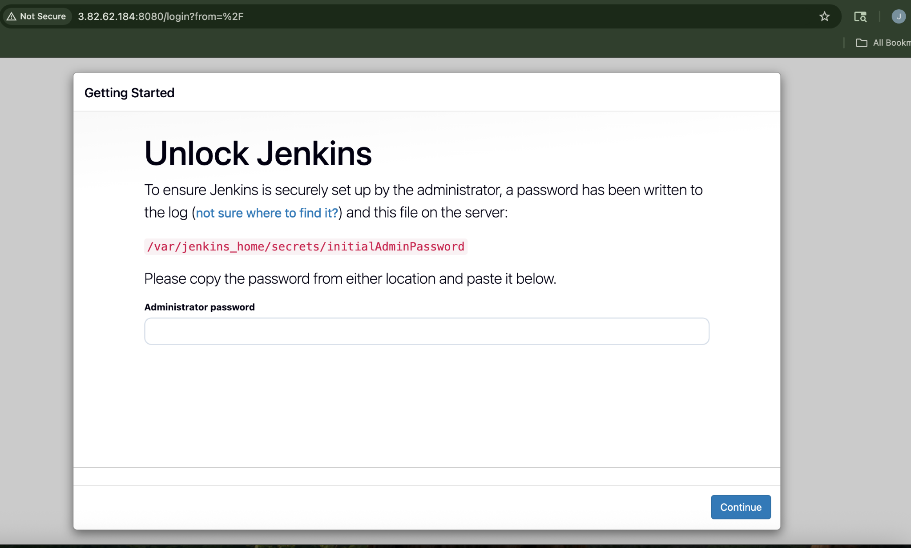
In Build steps→Execute shell→

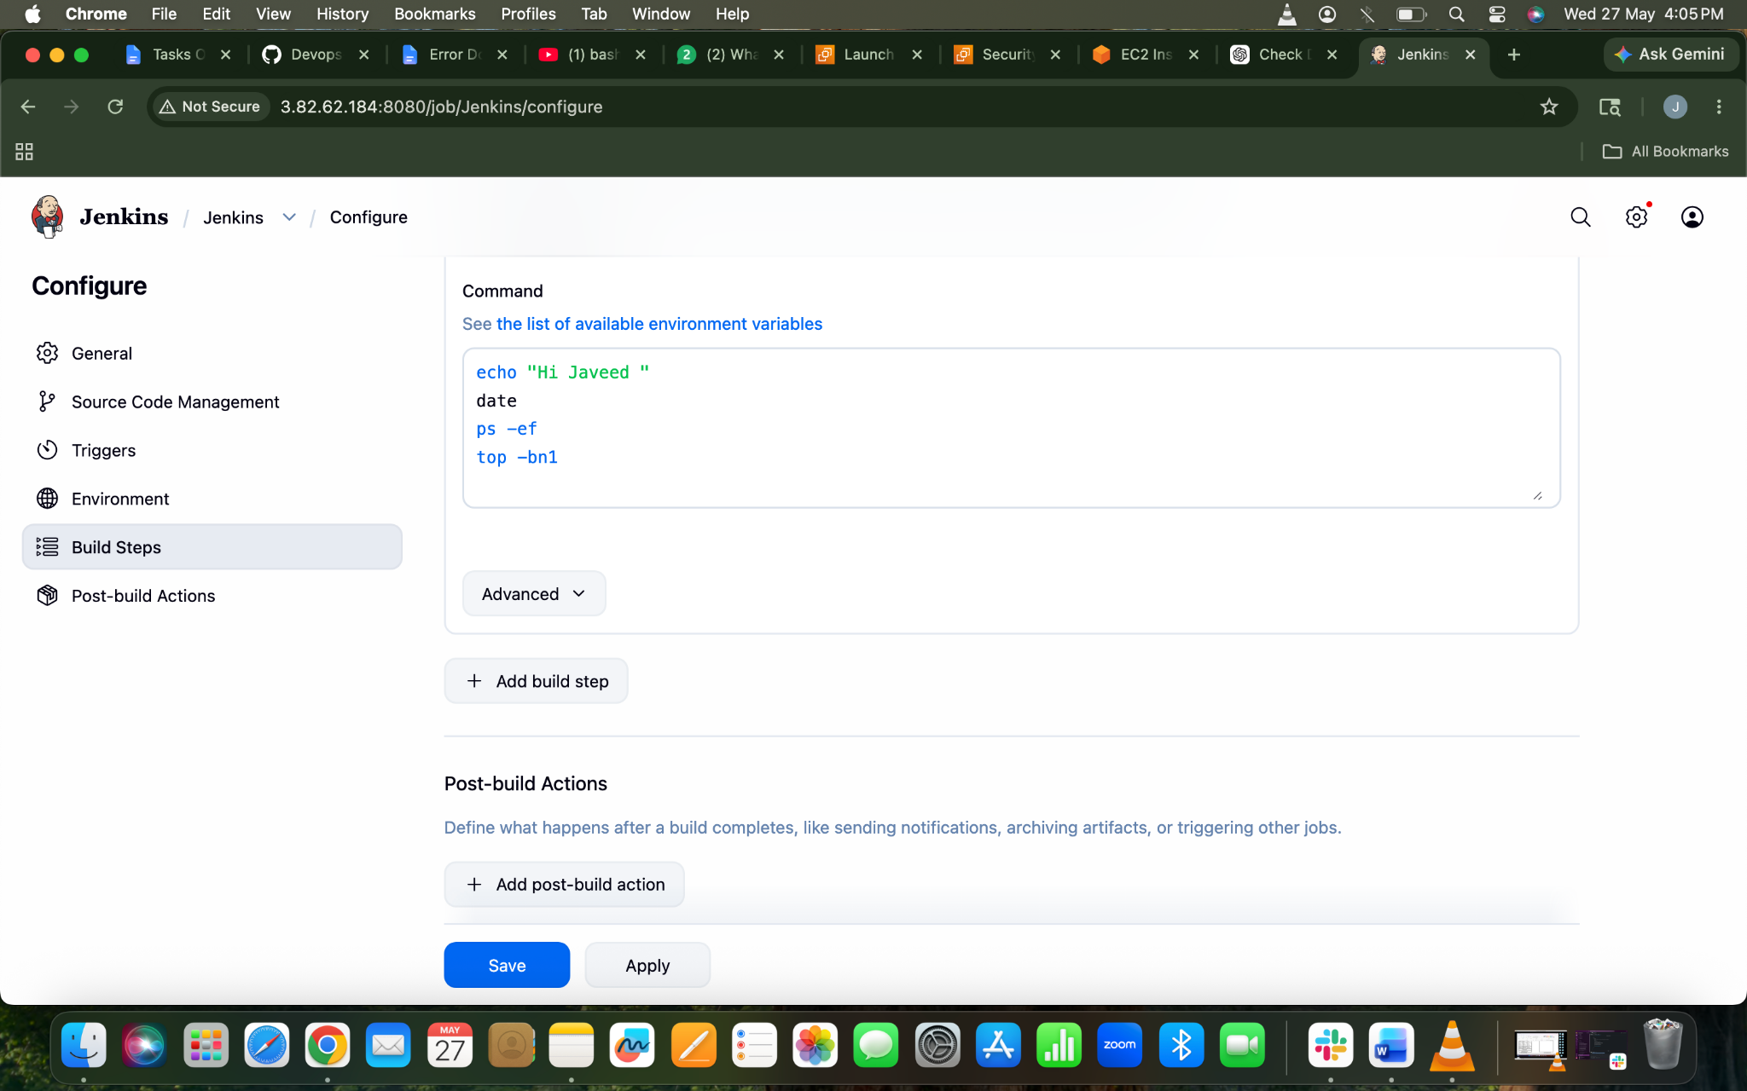
Now run the Job
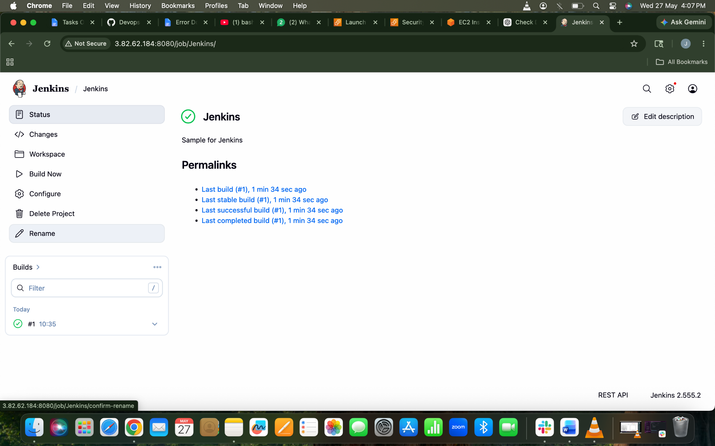
Let check the console output
